Daekyo Co., Ltd.
Non-Consolidated Financial Statements
December 31, 2006 and 2005

Page(s)

Report of Independent Auditors …………………………………………………………… 1 ~ 2
Non-Consolidated Financial Statements
Balance Sheets ……………………………………………………………………………… 3 ~ 4
Statements of Income ……………………..………………………………………………… 5~ 6
Statements of Appropriations of Retained Earnings ………………………………………….7
Statements of Cash Flows …………………………………………………………………….. 8 ~ 10
Notes to Non-Consolidated Financial Statements ………………………………………….....11 ~ 45
Report on the Review of Internal Accounting Control System ……..…………………. 46 ~ 47
Report on the Operation of the Internal Accounting Control System ……..…………… 48

Report of Independent Auditors

To the Board of Directors and Shareholders of
Daekyo Co., Ltd.
We have audited accompanying balance sheets of Daekyo Co.,Ltd.(The “Company”) as of December 31,2006 and 2005, and the related statement of income, appropriations of retained earnings and cash flows for the years then ended, expressed in Korean won.. These financial statements are the responsibility of the Company’s management. Our responsibility is to express an opinion on these financial statements based in our audits.
We conducted our audits in accordance with auditing standards generally accepted in the Republic of Korea. Those standards require that we plan and perform the audit to obtain reasonable assurance about whether the financial statements are free of material misstatement. An audit includes examining, on a test basis, evidence supporting the amounts and disclosures in the financial statements An audit also includes evaluating the overall financial statement presentation. We believe that our audits provide a reasonable basis for our opinion.
In our opinion, the non-consolidated financial statements referred to above present fairly, in all material respects, the financial position of Daekyo Co..,Ltd. as of December 21, 2006 and 2005, and the results of its operations, the changes in its retained earnings and its cash flows for the years then ended in conformity with accounting principles generally accepted in the republic of Korea.

Samil PricewaterhouseCoopers

Accounting principles and auditing standards and their application in practice vary among countries. The accompanying financial statements are not intended to present the financial position, results of operations and cash flows in conformity with accounting principles and practices generally accepted in countries and jurisdictions other than the Republic of Korea. In addition, the procedures and practices used in the Republic of Korea to audit such financial statements may differ from those generally accepted and applied in other countries. Accordingly, this report and the accompanying financial statements are for use by those who are informed about Korean accounting principles or auditing standards and their application in practice.

Seoul, Korea
March 5, 2007

This report is effective as of March 5, 2007, the audit report date. Certain subsequent events or circumstances, which may occur between the audit report date and the time of reading this report, could have a material impact on the accompanying non-consolidated financial statements and notes thereto. Accordingly, the readers of the audit report should understand that there is a possibility that the above audit report may have to be revised to reflect the impact of such subsequent events or circumstances, if any.

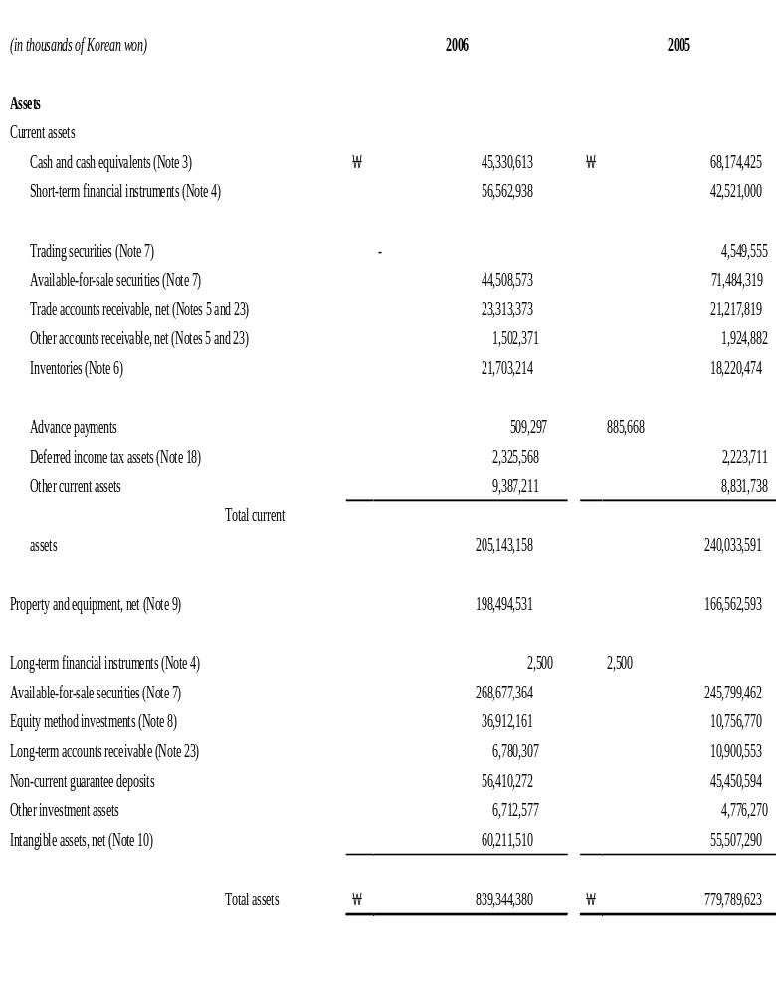

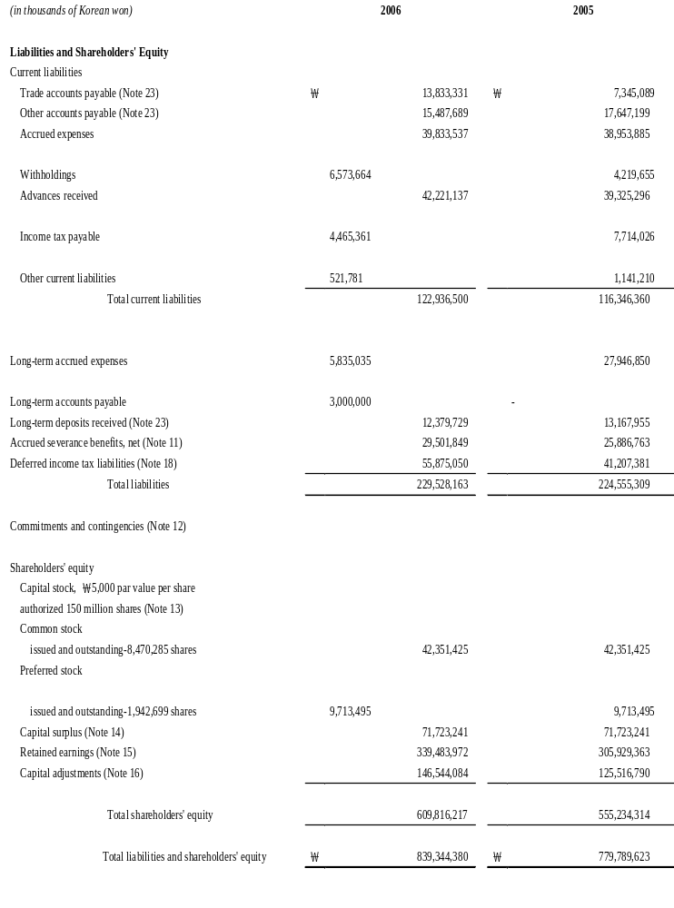

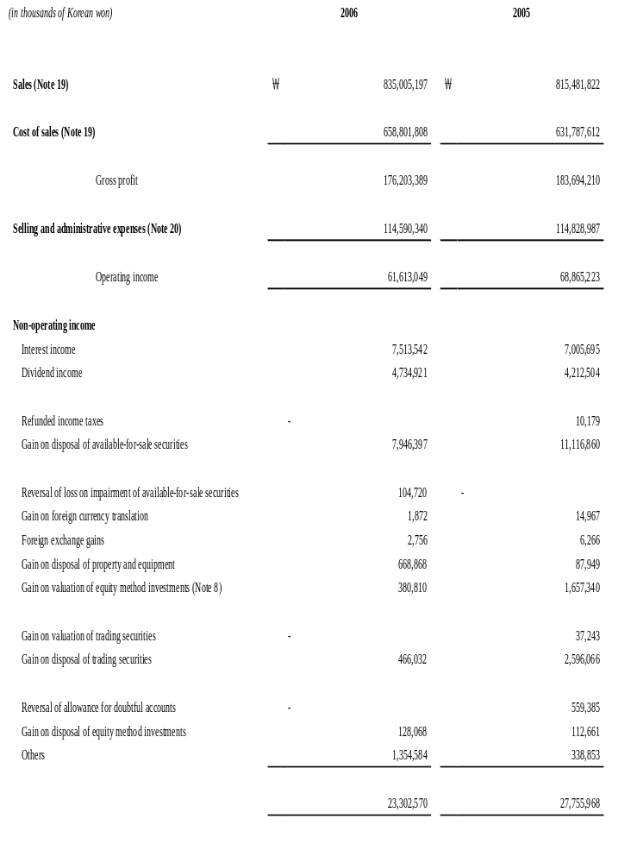

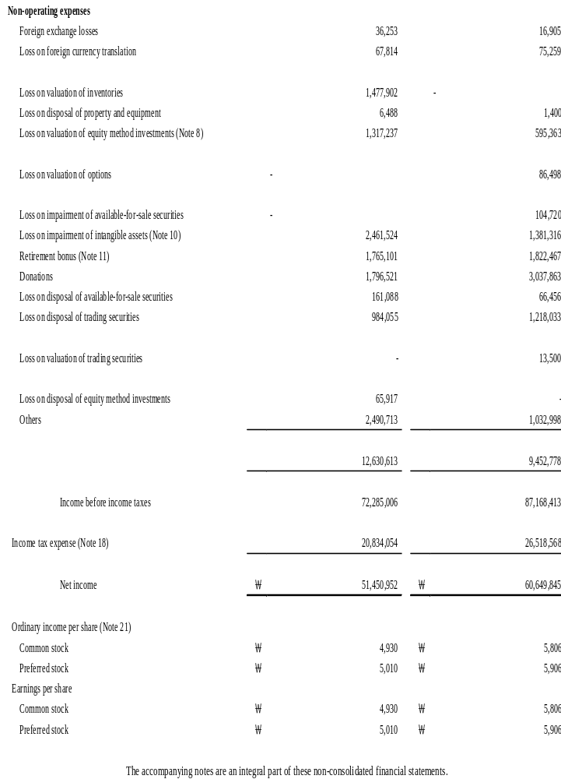

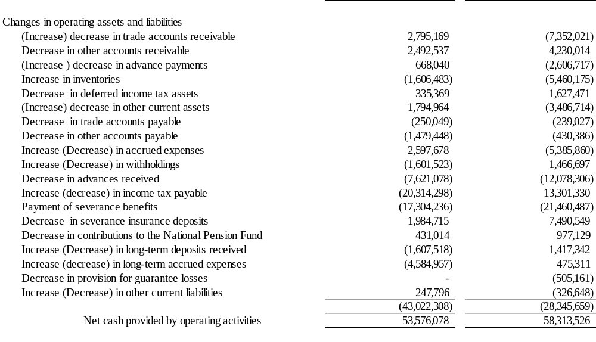

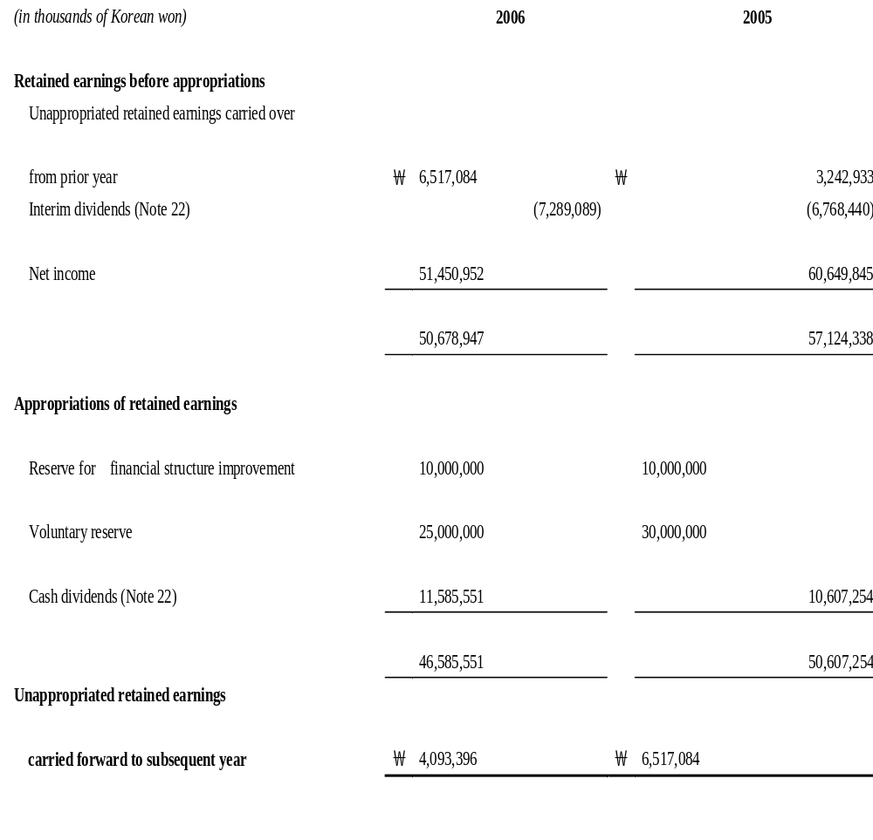

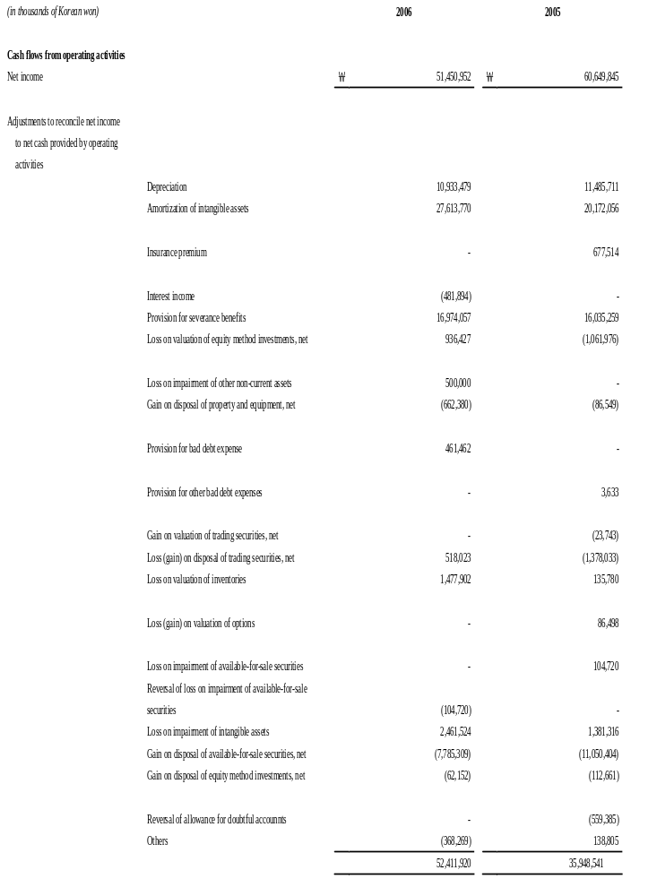

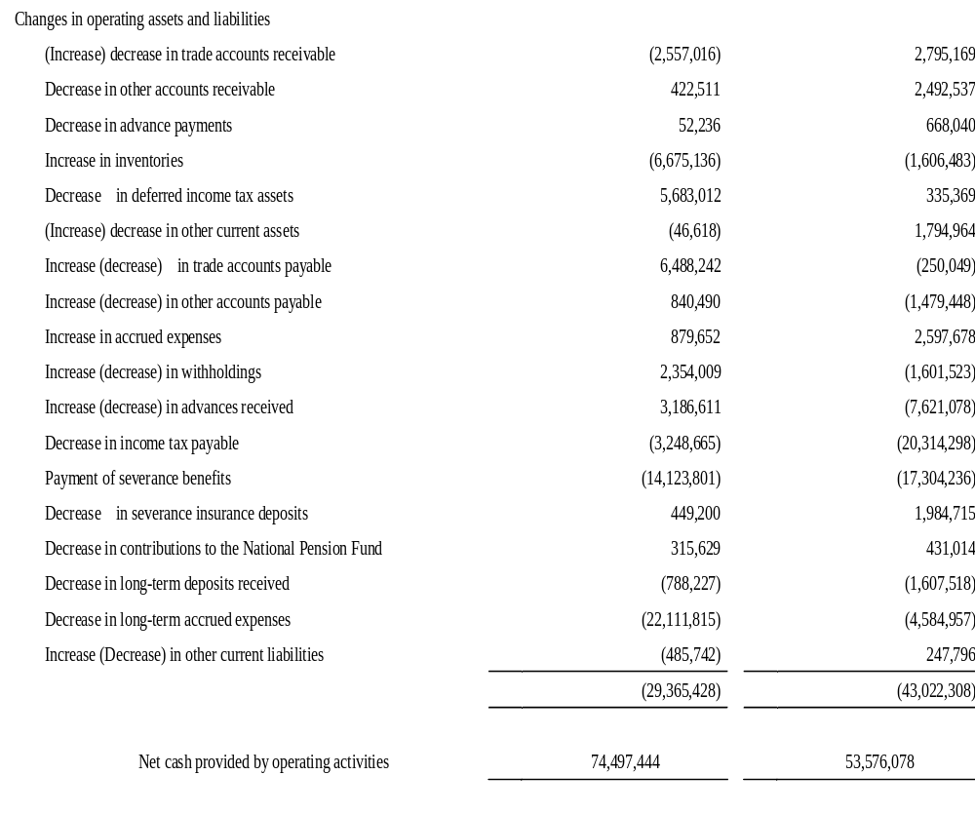

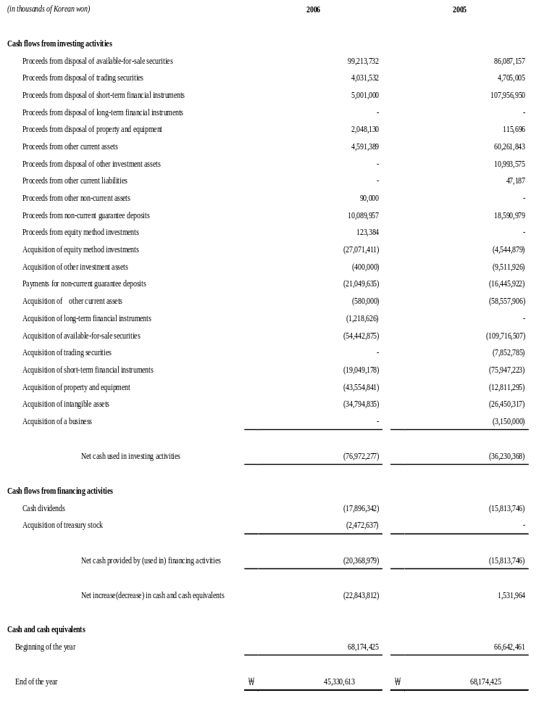

1. The Company

Daekyo Co., Ltd. (the "Company") was incorporated in December 1986 under the Commercial Code of the Republic of Korea to provide educational services for children. The Company changed its name from Daekyo Munhwa Co., Ltd. to Daekyo Co., Ltd. in January 1991.

As of December 31, 2006, the Company’s shareholders of common stock are as follows:

 |  | Number of  Shares |  | Percentage of  ownership (%)
Daekyo Holdings Co., Ltd. |  | 4,617,120 |  | 54.51
Daekyo Culture Foundation |  | 297,842 |  | 3.52
Kang, Young Jung |  | 183,234 |  | 2.16
Others |  | 3,372,089 |  | 39.81
 |  | 8,470,285 |  | 100.00

On February 3, 2004, the Company offered its shares for public ownership by listing its common shares on the Korean Stock Exchange, and issued 1,310,552 shares of common stock through public subscription and 689,448 shares of treasury stock through sale, with total proceeds of ￦84,000 million, at ￦42,000 per share.

2. Summary of Significant Accounting Policies

The significant accounting policies followed by the Company in the preparation of its non-consolidated financial statements are summarized below:

Basis of Financial Statement Presentation
The Company maintains its accounting records in Korean won and prepares statutory financial statements in the Korean language (Hangul) in conformity with the accounting principles generally accepted in the Republic of Korea. Certain accounting principles applied by the Company that conform with financial accounting standards and accounting principles in the Republic of Korea may not conform with generally accepted accounting principles in other countries. Accordingly, these financial statements are intended for use by those who are informed about Korean accounting principles and practices. The accompanying non-consolidated financial statements have been condensed, restructured and translated into English from the Korean language non-consolidated financial statements. Certain information attached to the Korean language financial statements, but not required for a fair presentation of the Company’s financial position, and results of operations, or cash flows, is not presented in the accompanying non-consolidated financial statements.

Accounting Estimates
The preparation of the financial statements requires management to make estimates and assumptions that affect amounts reported therein. Although these estimates are based on management’s best knowledge of current events and actions that the Company may undertake in the future, actual results may differ from those estimates.

Application of the Statements of Korean Financial Accounting Standards
The Korean Accounting Standards Board has published a series of Statements of Korean Financial Accounting Standards (“SKFAS”), which will gradually replace the existing financial accounting standards established by the Korean Financial Supervisory Commission. As SKFAS Nos. 18 through 20 became applicable to the Company on January 1, 2006, the Company adopted these standards in its financial statements covering periods beginning January 1, 2006.
Revenue Recognition
Sales of products are recognized upon delivery when the significant risks and rewards of ownership of the products are transferred to the buyer.
Cash and Cash Equivalents
The Company considers cash on hand, bank deposits and highly liquid marketable securities with original maturities of three months or less to be cash and cash equivalents.

Allowance for Doubtful Accounts
The Company provides an allowance for doubtful receivables based on the aggregate estimated collectibility of the receivables.

Return reserve
Estimated returns and related estimated cost of goods sold are deducted from sales and cost of goods sold, respectively.

Inventories
The Company accounts for inventories under the provision of SKFAS No.10, Inventories.

Inventories are stated at the lower of cost or market, with cost being determined using the moving-average method, except for materials-in-transit, which are stated at actual cost using the specific identification method. If the net realizable value of inventory is less than its cost, the carrying amount is reduced to the net realizable value. If, however, the circumstances which caused the valuation loss cease to exist, the valuation loss is reversed up to the original carrying amount before valuation. The said reversal is a deduction from cost of sales.

Investments in Securities
The Company accounts for equity and debt securities under the provision of SKFAS No. 8, Investments in Securities . This statement requires investments in equity and debt securities to be divided into three categories: trading, available-for-sale and held-to-maturity.

Securities are initially carried at cost, including incidental expenses, with cost being determined using the moving-average method. Debt securities, which the Company has the intent and ability to hold to maturity, are generally carried at cost, adjusted for the amortization of discounts or premiums. Premiums and discounts on debt securities are amortized over the term of the debt using the effective interest rate method. Trading and available-for-sale securities are carried at fair value, except for non-marketable securities classified as available-for-sale securities, which are carried at cost. Non-marketable debt securities are carried at a value using the present value of future cash flows, discounted at a reasonable interest rate determined considering the credit ratings provided by the independent credit rating agencies.

Unrealized valuation gains or losses on trading securities are charged to current operations, and those resulting from available-for-sale securities are recorded as a capital adjustment, the accumulated amount of which shall be charged to current operations when the related securities are sold, or when an impairment loss on the securities is recognized. Impairment losses are recognized in the income statement when the recoverable amounts are less than the acquisition cost of securities or adjusted cost of debt securities for the amortization of discounts or premiums.

Equity-Method Investments
Investments in equity securities of companies, over which the Company exercises a significant control or influence are recorded using the equity method of accounting. Under the equity method, the Company records changes in its proportionate ownership in the book value of the investees in current operations, as capital adjustments or as adjustments to retained earnings, depending on the nature of the underlying change in the book value of the investee.
The Company discontinues the application of the equity method of accounting for investments in equity method investees when the book value of the investments becomes zero or below as a result of reflecting the Company’s share in the accumulated losses of the investee. The Company resumes the application of the equity method when there are changes in its proportionate ownership in the book value of the investees, as a result of the subsequent changes in its proportionate net income of the investees less its cumulative proportionate net losses not recognized during the periods when the equity method was suspended.
The Company assesses the potential impairment of equity-method investments when there is significant difference between book value and the estimated realizable value. The book value of the investments is reduced to its estimated realizable value by recording an impairment loss charged to current operations and presenting it as a reduction from the said book value. However, any recovery of the impaired investments is recorded in current operations and should not exceed the carrying amount of the investments before impairment.
Difference of initial purchase price over the Company’s initial proportionate ownership in the net book value of the investee is amortized over the relevant period, not to exceed 20 years, using the straight-line method and the amortization is charged to current operations. An excess of the initial proportionate ownership over the purchase price is recognized as income on straight-line basis over the remaining weighted average useful life of the identifiable acquired depreciable asset or at the date of purchasing, depending on the nature of the excess, not related to the losses or expenses expected to occur in the future.
Unrealized profit arising from sales between the Company and the equity-method investees is eliminated based on the percentage of ownership.
Foreign currency financial statements of equity method investees are translated into Korean won using the exchange rate in effect as of the balance sheet date for assets and liabilities, and annual average exchange rate for income and expenses. Any resulting translation gain or loss is included in the capital adjustment account as gain or loss on valuation of equity method investments, a component of shareholders' equity.
Property and Equipment
Property, plant and equipment are stated at cost, which includes acquisition cost, production cost and other costs required to prepare the asset for its intended use. It also includes the present value of the estimated cost of dismantling and removing the asset, and restoring the site after the termination of the asset's useful life, provided it meets the criteria for recognition of provisions.

Property and equipment are stated at cost, net of accumulated depreciation. Depreciation is computed using the straight-line method for buildings and structures and the declining-balance method for other property and equipment over the estimated useful lives of the related assets as described below:

 |  | Estimated useful lives
Buildings |  | 40 - 60 years
Structures |  | 3 - 40 years
Machinery |  | 4 years
Vehicles |  | 2 - 5 years
Tools |  | 2 - 6 years
Equipment |  | 2 - 17 years

Routine maintenance and repairs are charged to current operations as incurred. Betterments and renewals, which enhance the value of the assets over their recently appraised value, are capitalized.

The Company assesses the potential impairment of property and equipment when there is evidence that events or changes in circumstances have made the recovery of an asset’s carrying value to be unlikely. The carrying value of the assets is reduced to the estimated realizable value and an impairment loss is recorded as a reduction in the carrying value of the related asset and charged to current operations. However, the recovery of the impaired assets is recorded in current operations up to the cost of the assets, net of accumulated depreciation before impairment, when the estimated value of the assets exceeds the carrying value after impairment.

Intangible Assets
Intangible assets are stated at cost, net of accumulated amortization. Amortization is computed using the straight-line method over the estimated useful lives as described below:

 |  | Estimated useful lives
Goodwill |  | 5 years
Industrial property rights |  | 5 - 10 years
Development costs |  | 4 years
Intellectual property rights |  | 5 years
Franchise |  | 5 years
Rights to use donated assets |  | 1 – 4 years
Software |  | 4 years

Development costs, directly relating to a new technology or new products whose estimated future benefits are probable, are capitalized as intangible assets.

The Company assesses the potential impairment of intangible assets when there is evidence that events or changes in circumstances have made the recovery of an asset’s carrying value to be unlikely. The carrying value of the assets is reduced to the estimated realizable value, and an impairment loss is recorded as a reduction in the carrying value of the related asset and charged to current operations. However, the recovery of the impaired assets is recorded in current operations up to the cost of the asset, net of accumulated amortization before impairment, when the estimated value of the assets exceeds the carrying value after impairment.

Foreign Currency Translation
Monetary assets and liabilities denominated in foreign currencies are translated into Korean won at the exchange rates in effect at the balance sheet date (US$1 : ￦929.6, ￥100 : ￦781.83, Canada$1 : ￦801.17, NZ$1 : ￦655.74, HK$1 : ￦119.59, AU$1 : ￦734.48, GBP1 : ￦1,824.11, EUR1 : ￦1,222.24, SGD$1 : 605.78, as of December 31, 2006), and the resulting translation gains and losses are recognized in current operations.

Accrued Severance Benefits
Employees and directors with at least one year of service are entitled to receive a lump-sum payment upon termination of their employment, based on their length of service and rate of pay at the time of termination. Accrued severance benefits represent the amount which would be payable assuming all eligible employees and directors were to terminate their employment as of the balance sheet date.

The Company has made deposits to the National Pension Fund in accordance with the National Pension Funds Law. The use of the deposit is restricted to the payment of severance benefits. Accordingly, accrued severance benefits in the accompanying balance sheet are presented net of these deposits.

Accrued severance benefits are funded through a group severance insurance plan and are presented as a deduction from accrued severance benefits.

Long-Term Accrued Expenses
The Company entered into contracts with freelance instructors to manage its educational service members. In accordance with the contracts, the Company pays instructors a certain amount based on cumulative cash collection amounts from its educational service members during the period of the contract. Long-term accrued expenses represent the amount which would be payable assuming all instructors were to terminate their contracts as of the balance sheet date.

Income Taxes Expenses and Deferred Income Tax Assets (liabilities)
The Company recognizes deferred income tax assets and liabilities, which represent temporary differences between the financial reporting and tax bases of assets and liabilities. Deferred income tax assets and liabilities are computed on such temporary differences, including available net operating loss carryforwards and tax credits, by applying enacted statutory tax rates applicable to the years when such differences are expected to reverse. Deferred income tax assets are recognized when it is more likely such deferred tax assets will be realized. The total income tax provision includes the current tax expense under applicable tax regulations and the change in the balance of deferred income tax assets and liabilities during the year.

In accordance with SKFAS No. 16, Deferred Income Tax, which became effective on January 1, 2005, the Company classified deferred income tax assets and liabilities into current and non-current, and within each classification, amounts for deferred tax assets and liabilities, which are related to the same tax authorities, are offset against each other and presented as net amount.

Derivatives
Derivative financial instruments for trading or hedging purpose are valued at estimated market price with the resulting unrealized gains or losses recognized in the current operations, except for the effective portion of derivative transactions entered into for the purpose of cash-flow hedges, which is recorded as a capital adjustment.
Provisions for Estimated Liabilities
The Company accrues expense and records a liability for a current obligation, resulting from past events but involving uncertainty as to possible loss, in the financial statements when both information available prior to the issuance of the financial statements indicates that it is probable that a liability has been incurred at the date of the financial statements and the amount of the loss can be reasonably estimated.
Contingent Liabilities
When there is a probability that an outflow of economic benefits will occur due to a present obligation resulting from a past event, and whose amount is reasonably estimable, a corresponding amount of provision is recognized in the financial statements. However, when such outflow or inflow is dependent upon a future event, is not certain to occur, or cannot be reliably estimated, a disclosure regarding the contingent liability in case of an outflow, or the contingent asset in case of an inflow, is made in the notes to the financial statements.
Contingent Assets
Gain contingencies are claims or rights, resulting from past events or transactions, from which an asset may be received or a liability reduced, but whose occurrence is uncertain. The Company discloses gain contingencies in the notes only when the probability is such high that a gain contingency will transpire and records in the financial statements such assets only when such a contingency materializes.
Loss on Impairment of Assets
The Company assesses the potential impairment of assets, except the assets valued as market value, when there is evidence that events or changes in circumstances have made the recovery of an asset’s carrying value to be unlikely. The carrying value of the assets is reduced to the estimated realizable value and an impairment loss is recorded as a reduction in the carrying value of the related asset and charged to current operations. However, the recovery of the impaired assets is recorded in current operations up to the cost of the assets, net of accumulated depreciation before impairment, when the estimated value of the assets exceeds the carrying value after impairment.

3. Monetary Assets Denominated in Foreign Currencies

Monetary assets denominated in foreign currencies as of December 31, 2006 and 2005, are as follows:

 |  | 2006 |  |  |  |  | 2005
(in thousands) |  | Korean Won  equivalent |  | Foreign  currency |  |  | Korean Won  equivalent |  | Foreign  currency
Cash and cash |  | ￦ 747,988 |  | US$ | 805 |  | ￦ 315,694 |  | US$ | 312
equivalents |  | 71,292 |  | CN$ | 89 |  | 76,801 |  | CN$ | 88
 |  | 112,828 |  | HK$ | 943 |  | 47,320 |  | HK$ | 362
 |  | 179,407 |  | NZ$ | 274 |  | 179,925 |  | NZ$ | 261
 |  | 154,995 |  | JP￥ | 19,825 |  | 53,865 |  | JP￥ | 6,264
 |  | 56,929 |  | AU$ | 78 |  | 38,481 |  | AU$ | 52
 |  | 26,835 |  | GBP | 15 |  | 20,848 |  | GBP | 12
 |  | 101,235 |  | EUR | 83 |  | 40,804 |  | EUR | 34
 |  | 77,279 |  | SG$ | 128 |  | 33,335 |  | SG$ | 55

4. Restricted Deposits

As of December 31, 2006 and 2005, long-term financial instruments amounting to ￦2,500 thousand represent key money deposits required to maintain checking accounts and accordingly, withdrawal of these deposits is restricted. As of December 31, 2006, short-term financial instruments amounting to ￦3,520,000 thousand (2005: ￦8,521,000 thousand), were provided as collaterals in connection with guarantees on affiliated companies and others.

5. Receivables

Receivables, including trade and other accounts receivable, as of December 31, 2006 and 2005, consist of the following:

 |  | 2006
(in thousands of Korean won) |  | Gross amount |  | Allowance for doubtful accounts |  | Discounts on present value |  | Carrying value
Trade accounts receivable |  | ￦27,243,247 |  | ￦ 3,929,874 |  | ￦ - |  | ￦23,313,373
Other accounts receivable |  | 2,831,338 |  | 1,328,967 |  | - |  | 1,502,371
 |  | ￦30,074,585 |  | ￦ 5,258,841 |  | ￦ - |  | ￦24,815,744

 |  | 2005
(in thousands of Korean won) |  | Gross amount |  | Allowance for doubtful accounts |  | Discounts on present value |  | Carrying value
Trade accounts receivable |  | ￦24,686,200 |  | ￦ 3,468,381 |  | ￦ - |  | ￦21,217,819
Other accounts receivable |  | 3,257,433 |  | 1,332,551 |  | - |  | 1,924,882
 |  | ￦27,943,633 |  | ￦ 4,800,932 |  | ￦ - |  | ￦23,142,701
6. Inventories

Inventories as of December 31, 2006 and 2005, consist of the following:

(in thousands of Korean won) |  | 2006 |  | 2005
Merchandise |  | ￦ 3,201,562 |  | ￦ 377,942
Finished products |  | 14,882,198 |  | 13,667,943
Supplies |  | 2,210,178 |  | 2,932,880
Raw materials |  | 1,409,276 |  | 1,241,709
 |  | ￦ 21,703,214 |  | ￦ 18,220,474

7. Marketable Securities

Trading securities as of December 31, 2006 and 2005, consist of the following:

(in thousands of Korean won) |  | 2006 |  | 2005
Equity securities |  | ￦ - |  | ￦ 4,549,555

Available-for-sale securities as of December 31, 2006 and 2005, consist of the following:

(in thousands of Korean won) |  | 2006 |  | 2005
Debt securities |  | ￦ 9,111,847 |  | ￦ 11,918,920
Equity securities |  | 304,074,090 |  | 305,364,860
 |  | ￦ 313,185,937 |  | ￦ 317,283,780

Debt securities included in available-for-sale securities as of December 31, 2006 and 2005, consist of the following:

(in thousands of Korean won) |  | 2006 |  | 2005
Convertible bonds |  | ₩ 500,000 |  | ₩ 1,071,304
Government and public bonds |  | 8,611,847 |  | 10,847,616
 |  | ￦ 9,111,847 |  | ￦ 11,918,920

Among the above debt securities, securities with maturities of less than one year or securities which are almost certain to be disposed of are classified as current assets. For the year ended December 31, 2006, total interest income from available-for-sale securities amounted to ￦481,894 thousand.
The carrying value and the fair value of available-for sale securities according to annual maturity, in aggregate, as of December 31, 2006 and 2005, are as follows:

(in thousands of Korean won) |  | 2006 |  |  |  | 2005
 |  | Carrying value |  | Fair value |  | Carrying value |  | Fair value
One year or less |  | ￦ 1,011,398 |  | ￦ 1,011,398 |  | ￦ 3,645,324 |  | ￦ 3,645,324
More than one year to five years |  | 8,100,449 |  | 8,100,449 |  | 8,248,816 |  | 8,248,816
More than five years to ten years |  | - |  | - |  | 24,780 |  | 24,780
 |  | ￦ 9,111,847 |  | ￦ 9,111,847 |  | ￦11,918,920 |  | ￦11,918,920

Equity securities included in available-for-sale securities as of December 31, 2006 and 2005, consist of the following:

 |  | 2006
 |  | Number of |  |  |  |  |  | Market or
 |  | shares |  | Percentage of |  | Acquisition |  | net asset |  | Carrying
(in thousands of Korean won) |  | owned |  | Ownership (%) |  | cost |  | value |  | value
Current assets
Beneficiary certificates¹ |  |  |  |  |  | ₩ 39,050,246 |  | ₩ 43,497,175 |  | ₩ 43,497,175
Non-current assets
Marketable equity securities
Shinhan Financial Group Co., Ltd. |  | 5,344,397 |  | 1.460 |  | 54,689,402 |  | 253,858,857 |  | 253,858,857
LG Electronics Inc. |  | 13,000 |  | 0.010 |  | 907,399 |  | 715,000 |  | 715,000
Daeshin Securities Co., Ltd. |  | 61,200 |  | 0.230 |  | 999,959 |  | 966,960 |  | 966,960
Binggrae Co.,Ltd |  | 8,700 |  | 0.080 |  | 291,191 |  | 370,620 |  | 370,620
Hyundai Mobis Co.,Ltd |  | 5,000 |  | 0.005 |  | 362,566 |  | 429,500 |  | 429,500
Cheil Communications Inc. |  | 200 |  | 0.004 |  | 21,305 |  | 46,200 |  | 46,200
CJ Home Shopping Corp. |  | 9,004 |  | 0.078 |  | 655,373 |  | 693,308 |  | 693,308
Hana Tour Service Inc. |  | 2,500 |  | 0.180 |  | 79,631 |  | 177,250 |  | 177,250
Donga Pharmaceutical Co,Ltd |  | 10,400 |  | 0.100 |  | 377,723 |  | 903,760 |  | 903,760
GS Home Shopping Inc. |  | 5,900 |  | 0.080 |  | 487,750 |  | 489,700 |  | 489,700
Inzi Contorols Co.,Ltd |  | 6,000 |  | 0.066 |  | 67,502 |  | 40,020 |  | 40,020
Duzon Digital Ware Co.,Ltd. |  | 27,000 |  | 0.240 |  | 393,948 |  | 580,500 |  | 580,500
Shinsegae Co., Ltd. |  | 500 |  | 0.002 |  | 231,226 |  | 290,000 |  | 290,000
Jinro Distillers Co., Ltd. |  | 7,000 |  | 0.100 |  | 126,468 |  | 134,400 |  | 134,400
Korea Zinc Co., Ltd. |  | 4,400 |  | 0.020 |  | 451,996 |  | 434,280 |  | 434,280
Kangwon Land Co., Ltd. |  | 4,000 |  | 0.000 |  | 80,357 |  | 80,800 |  | 80,800
Daewoong Pharmaceutical Co., Ltd. |  | 3,700 |  | 0.030 |  | 214,576 |  | 217,560 |  | 217,560
LG Household & Health Co., Ltd. |  | 1,200 |  | 0.000 |  | 115,568 |  | 148,200 |  | 148,200
 |  |  |  |  |  | 60,553,940 |  | 260,576,915 |  | 260,576,915
 |  |  |  |  |  | ₩ 99,604,186 |  | ₩304,074,090 |  | ₩304,074,090

 |  | 2005
 |  | Number of |  |  |  |  |  | Market or
 |  | shares |  | Percentage of |  | Acquisition |  | net asset |  | Carrying
(in thousands of Korean won) |  | owned |  | Ownership (%) |  | cost |  | value |  | value
Current assets
Beneficiary certificates¹ |  |  |  |  |  | ￦ 63,050,245 |  | ￦ 67,838,994 |  | ￦ 67,838,994
Non-current assets
Marketable equity securities
Shinhan Financial Group Co., Ltd. ² |  | 5,344,397 |  | 1.588 |  | 54,690,402 |  | 219,387,497 |  | 219,387,497
LG Telecom Ltd. ³ |  | 1,035,652 |  | 0.370 |  | 5,395,747 |  | 6,876,729 |  | 6,876,729
KT Corporation |  | 132,000 |  | 0.046 |  | 5,685,879 |  | 5,392,200 |  | 5,392,200
LG Electronics Inc. |  | 13,000 |  | 0.009 |  | 907,399 |  | 1,160,900 |  | 1,160,900
Binggrae Co.,Ltd |  | 10,000 |  | 0.100 |  | 333,694 |  | 398,500 |  | 398,500
Hyundai Mobis Co.,Ltd |  | 5,000 |  | 0.012 |  | 362,567 |  | 462,000 |  | 462,000
Cheil Communications Inc. |  | 1,700 |  | 0.037 |  | 282,051 |  | 374,850 |  | 374,850
CJ Home Shopping Corp. |  | 6,300 |  | 0.070 |  | 465,669 |  | 783,720 |  | 783,720
Hana Tour Service Inc. |  | 15,000 |  | 0.140 |  | 323,942 |  | 720,000 |  | 720,000
Donga Pharmaceutical Co.,Ltd. |  | 10,000 |  | 0.100 |  | 362,132 |  | 870,000 |  | 870,000
GS Home Shopping Inc. |  | 5,030 |  | 0.070 |  | 415,520 |  | 648,870 |  | 648,870
S1 Corporation |  | 2,000 |  | 0.005 |  | 80,301 |  | 87,600 |  | 87,600
Insun Environmental New Technology Co. |  | 11,000 |  | 0.090 |  | 233,168 |  | 148,500 |  | 148,500
Inzi Contorols Co.,Ltd |  | 6,000 |  | 0.039 |  | 67,503 |  | 63,000 |  | 63,000
Duzon Digital Ware Co.,Ltd. |  | 10,000 |  | 0.116 |  | 261,637 |  | 151,500 |  | 151,500
 |  |  |  |  |  | 69,867,611 |  | 237,525,866 |  | 237,525,866
 |  |  |  |  |  | ￦132,917,856 |  | ￦305,364,860 |  | ￦305,364,860
¹ The beneficiary certificates are classified as current assets because the certificates mature within one year or is almost certain to be disposed of within one year.

² Shinhan Life Insurance became a 100% subsidiary of Shinhan Financial Group on December 13, 2005, through a comprehensive stock swap, which was decided at Shinhan Life Insurance’s special stockholders meeting held on October 14, 2005. The Company valued the Shinhan Financial Group shares acquired through this swap using the Shinhan Life Insurance’s book value amount of ￦ 38,885,480 thousand.

The Company recognized an amount of ￦ 73,229,992 thousand as capital adjustment, representing the difference between the book value amount and the fair market value amount of ￦ 139,892,366 thousand as of December 31, 2005, net of tax effect amount of ￦ 27,776,894 thousand.

³ The 350,000 shares of this investment were lent under a certain contract with regard to derivative transactions as of December 31, 2005. The investment was disposed of in 2006
The unrealized gain(loss) on valuation of available-for-sale securities, which is accounted for as a capital adjustment, for the years ended December 31, 2006 and 2005, is as follows:

 |  | 2006
(In thousands of Korean won) |  | Beginning  balance |  | Increase (decrease) |  | Disposal (realization) |  | Ending  balance
Dongbu Securities Co., Ltd convertible bond |  | ₩ 32,933 |  | ₩ (44,496) |  | ₩ 11,563 |  | ₩ -
Government and public bonds |  | 135,317 |  | 145,558 |  | 89,786 |  | 370,661
Shinhan Financial Group Co., Ltd. |  | 119,405,394 |  | 24,991,736 |  | - |  | 144,397,130
LG Telecom Ltd. |  | 1,073,712 |  | 640,465 |  | (1,714,177) |  | -
KT Corporation |  | (212,917) |  | (4,785) |  | 217,702 |  | -
LG Electronics Inc. |  | 183,788 |  | (323,277) |  | - |  | (139,489)
Daeshin Securities Co., Ltd. |  | - |  | (23,925) |  | - |  | (23,925)
Binggrae Co.,Ltd |  | 46,984 |  | 2,642 |  | 7,960 |  | 57,586
Hyundai Mobis Co.,Ltd |  | 72,089 |  | (23,562) |  | - |  | 48,527
Cheil Communications Inc. |  | 67,279 |  | (508) |  | (48,722) |  | 18,049
CJ Home Shopping Corp. |  | 230,587 |  | (203,084) |  | - |  | 27,503
Hana Tour Service Inc. |  | 287,142 |  | 218,060 |  | (434,428) |  | 70,774
Donga Pharmaceutical Co,Ltd |  | 368,204 |  | 13,173 |  | - |  | 381,377
GS Home Shopping Inc. |  | 169,179 |  | (167,765) |  | - |  | 1,414
S1 Corporation |  | 5,292 |  | 1,222 |  | (6,514) |  | -
Insun Environmental New Technology Co. |  | (61,384) |  | (37,120) |  | 98,504 |  | -
Inzi Contorols Co.,Ltd |  | (3,265) |  | (16,660) |  | - |  | (19,925)
Duzon Digital Ware Co.,Ltd. |  | (79,849) |  | 215,099 |  | - |  | 135,250
Shinsegae Co., Ltd. |  | - |  | 42,612 |  | - |  | 42,612
Jinro Distillers Co., Ltd. |  | - |  | 5,751 |  | - |  | 5,751
Korea Zinc |  | - |  | (12,844) |  | - |  | (12,844)
Kangwon Land Co., Ltd. |  | - |  | 322 |  | - |  | 322
Daewoong Pharmaceutical Co., Ltd. |  | - |  | 2,164 |  | - |  | 2,164
LG Household & Health Co., Ltd. |  | - |  | 23,658 |  | - |  | 23,658
Beneficiary certificates |  | 3,471,843 |  | 1,651,854 |  | (1,899,674) |  | 3,224,023
 |  | ￦ 125,192,328 |  | ￦ 27,096,290 |  | ￦ (3,678,000) |  | ￦ 148,610,618

 |  | 2005
(In thousands of Korean won) |  | Beginning  balance |  | Increase (decrease) |  | Disposal (realization) |  | Ending  balance
KT Corporation exchangeable bonds |  | ￦ (9,900) |  | ￦ - |  | ￦ 9,900 |  | ￦ -
Samsung Card Co., Ltd. convertible bond |  | 51,755 |  | - |  | (51,755) |  | -
LG Card Co., Ltd. convertible bond |  | 149,576 |  | - |  | (149,576) |  | -
Dongbu Securities Co., Ltd convertible bond |  | - |  | 32,933 |  | - |  | 32,933
Government and public bonds |  | 85,982 |  | 48,980 |  | 355 |  | 135,317
Shinhan Financial Group Co., Ltd. |  | 37,129,504 |  | 83,117,283 |  | (841,393) |  | 119,405,394
LG Telecom Ltd. |  | (1,253,139) |  | 1,912,590 |  | 414,261 |  | 1,073,712
KT Corporation |  | (207,879) |  | (71,038) |  | 66,000 |  | (212,917)
Samsung Electronics Co., Ltd. |  | 336,354 |  | - |  | (336,354) |  | -
LG Electronics Inc. |  | - |  | 183,788 |  | - |  | 183,788
Woori Finance Holdings Co., Ltd. |  | 185,159 |  | - |  | (185,159) |  | -
Hyundai Motor Company |  | 291,375 |  | - |  | (291,375) |  | -
Binggrae Co.,Ltd |  | - |  | 46,984 |  | - |  | 46,984
Hyundai Mobis Co.,Ltd |  | - |  | 72,089 |  | - |  | 72,089
Cheil Communications Inc. |  | - |  | 67,279 |  | - |  | 67,279
CJ Home Shopping Corp. |  | - |  | 230,587 |  | - |  | 230,587
Hana Tour Service Inc. |  | - |  | 287,142 |  | - |  | 287,142
Donga Pharmaceutical Co,Ltd |  | - |  | 368,204 |  | - |  | 368,204
GS Home Shopping Inc. |  | - |  | 169,179 |  | - |  | 169,179
S1 Corporation |  | - |  | 71,358 |  | (66,066) |  | 5,292
Insun Environmental New Technology Co. |  | - |  | (61,384) |  | - |  | (61,384)
Inzi Contorols Co.,Ltd |  | - |  | (3,265) |  | - |  | (3,265)
Duzon Digital Ware Co.,Ltd. |  | - |  | (79,849) |  | - |  | (79,849)
Beneficiary certificates |  | 1,974 |  | 3,720,304 |  | (250,435) |  | 3,471,843
 |  | ￦ 36,760,761 |  | ￦ 90,113,164 |  | ￦ (1,681,597) |  | ￦ 125,192,328

8. Equity Method Investments

Equity method investments as of December 31, 2006 and 2005, consist of the following:

 |  | 2006
(in thousands of Korean won) |  | Number of shares  owned |  | Percentage of  ownership (%) |  | Acquisition  cost |  | Market or  net asset value |  | Carrying  value
Daekyo Bertelsmann Korea  Co., Ltd. |  | 600,000 |  | 75.00 |  | ₩ 4,165,550 |  | ₩ 7,439,863 |  | ₩ 5,746,173
Daekyo America, Inc. |  | 209 |  | 63.53 |  | 960,656 |  | 678,602 |  | 650,875
Daekyo Hongkong Co., Ltd. |  | 2,272,727 |  | 47.89 |  | 250,000 |  | 247,919 |  | 242,362
Beijing Daekyo Co., Ltd. ¹ |  | - |  | 100.00 |  | 445,142 |  | 354,741 |  | 354,741
Yanbian Daekyo Co., Ltd. ¹ |  | - |  | 84.62 |  | 166,390 |  | 44,428 |  | 44,428
Daekyo Educonsulting  Co., Ltd.² |  | 36,138 |  | 100.00 |  | 501,800 |  | 1,612,266 |  | 1,612,266
Interesting Creative Co., Ltd. |  | 64,738 |  | 20.00 |  | 680,000 |  | - |  | -
Daekyo EOL Co., Ltd. |  | 12,210 |  | 56.53 |  | 842,490 |  | 70,610 |  | 70,610
Daekyo Malaysia Sdn. Bhd. |  | 1,940,988 |  | 100.00 |  | 599,793 |  | 219,722 |  | 206,094
Sanghai Daekyo Co., Ltd.¹ |  | - |  | 100.00 |  | 274,843 |  | 245,027 |  | 243,430
Daekyo U.S.A Inc. |  | 333 |  | 66.60 |  | 558,557 |  | 493,283 |  | 491,657
Daekyo Bertelsmann  Educational Service Limited. |  | 483,000 |  | 50.00 |  | 591,939 |  | 263,280 |  | 263,280
Fermatedu Co., Inc. |  | 480,000 |  | 51.00 |  | 26,564,000 |  | 9,999,113 |  | 26,056,291
Child-Care Consortium |  | 1,600 |  | 18.32 |  | 1,728,068 |  | 929,954 |  | 929,954
 |  |  |  |  |  | ￦38,329,228 |  | ￦ 22,598,808 |  | ￦ 36,912,161

 |  | 2005
(in thousands of Korean won) |  | Number of shares  owned |  | Percentage of  ownership (%) |  | Acquisition  cost |  | Market or  net asset value |  | Carrying  value
Daekyo Bertelsmann Korea  Co., Ltd. |  | 600,000 |  | 75.00 |  | ￦ 4,165,550 |  | ￦ 9,909,973 |  | ￦ 5,561,609
Daekyo America, Inc. |  | 209 |  | 63.53 |  | 960,656 |  | 708,237 |  | 680,103
Daekyo Hongkong Co., Ltd. |  | 2,272,727 |  | 47.89 |  | 250,000 |  | 301,837 |  | 301,837
Daekyo Japan Co., Ltd. |  | 508 |  | 100.00 |  | 258,748 |  | 143,879 |  | 141,414
Beijing Daekyo Co., Ltd. ¹ |  | - |  | 100.00 |  | 445,142 |  | 325,080 |  | 325,080
Yanbian Daekyo Co., Ltd. ¹ |  | - |  | 84.62 |  | 166,390 |  | 44,428 |  | 44,428
Daekyo Corein Co., Ltd. ² |  | 23,200 |  | 72.50 |  | 195,200 |  | 803,904 |  | 803,904
Daekyo Eduvision Co., Ltd. ² |  | 37,980 |  | 67.01 |  | 306,600 |  | 662,191 |  | 662,191
MyfriendNet Co., Ltd. |  | 33,334 |  | 30.30 |  | 333,340 |  | 48,775 |  | 48,775
Interesting Creative Co., Ltd. |  | 64,738 |  | 20.00 |  | 680,000 |  | - |  | -
Daekyo EOL Co., Ltd. |  | 12,210 |  | 56.53 |  | 842,490 |  | - |  | -
Daekyo Malaysia Sdn. Bhd. |  | 1,940,988 |  | 100.00 |  | 599,793 |  | 234,836 |  | 234,836
Sanghai Daekyo Co., Ltd.¹ |  | - |  | 100.00 |  | 274,843 |  | 245,642 |  | 243,828
Daekyo U.S.A Inc. |  | 486 |  | 66.60 |  | 558,557 |  | 494,823 |  | 494,823
Child-Care Consortium |  | 1,600 |  | 21.87 |  | 1,600,000 |  | 1,129,413 |  | 1,129,413
Daekyo Bertelsmann  Educational Service Limited |  | 70,500 |  | 50.00 |  | 84,529 |  | 84,529 |  | 84,529
 |  |  |  |  |  | ￦11,721,838 |  | ￦ 15,137,547 |  | ￦ 10,756,770

¹ No shares are issued according to the local laws and regulations.

² Daekyo Corein Co., Ltd. and Daekyo Eduvision Co., Ltd., entered into a business combination on July 3, 2006, after which the company’s name changed to Daekyo Educonsulting Co., Ltd.

The details of the equity method valuation as of December 31, 2006 and 2005, are as follows:

 |  | 2006
(in thousands of Korean won) |  | Acquisition cost |  | Retained earnings |  | Gain (loss) on valuation |  | Capital adjustment |  | Dividends |  | Carrying value
Daekyo Bertelsmann Korea  Co., Ltd. |  | ₩ 4,165,550 |  | ₩ 1,396,060 |  | ₩ 185,126 |  | ₩ (563) |  | ₩ - |  | ₩ 5,746,173
Daekyo America, Inc. |  | 960,656 |  | (481,001) |  | 29,411 |  | 141,809 |  | - |  | 650,875
Daekyo Hongkong Co., Ltd. |  | 250,000 |  | (30,102) |  | (35,407) |  | 57,871 |  | - |  | 242,362
Daekyo Japan Co., Ltd. |  | 258,748 |  | (229,865) |  | (28,883) |  | - |  | - |  | -
Beijing Daekyo Co., Ltd. |  | 445,142 |  | (67,847) |  | 46,928 |  | (69,482) |  | - |  | 354,741
Yanbian Daekyo Co., Ltd. |  | 166,390 |  | (110,727) |  | - |  | (11,235) |  | - |  | 44,428
Daekyo Educonsulting  Co., Ltd¹ |  | 501,800 |  | 681,488 |  | (96,277) |  | 525,255 |  | - |  | 1,612,266
Interesting Creative Co., Ltd. |  | 680,000 |  | (680,000) |  | - |  | - |  | - |  | -
Daekyo EOL Co., Ltd. |  | 842,490 |  | (842,490) |  | 70,610 |  | - |  | - |  | 70,610
Daekyo Malaysia Sdn. Bhd. |  | 599,793 |  | (301,331) |  | (24,309) |  | (68,059) |  | - |  | 206,094
Sanghai Daekyo Co., Ltd.¹ |  | 274,843 |  | 7,619 |  | 12,323 |  | (51,355) |  | - |  | 243,430
Daekyo U.S.A Inc. |  | 558,557 |  | (56) |  | 36,412 |  | (103,256) |  | - |  | 491,657
Daekyo Bertelsmann  Educational Service Limited |  | 591,939 |  | - |  | (313,777) |  | (14,882) |  | - |  | 263,280
Fermatedu Co., Inc. |  | 26,564,000 |  | - |  | (507,709) |  | - |  | - |  | 26,056,291
Child-Care Consortium |  | 1,728,068 |  | (487,239) |  | (310,875) |  | - |  | - |  | 929,954
 |  | ￦38,587,976 |  | ￦ (1,145,491) |  | ￦ (936,427) |  | ￦ 406,103 |  | ￦ - |  | ￦36,912,161

 |  | 2005
(in thousands of Korean won) |  | Acquisition cost |  | Retained earnings |  | Gain (loss) on valuation |  | Capital adjustment |  | Dividends |  | Carrying value
Daekyo Bertelsmann Korea  Co., Ltd. |  | ￦ 4,165,550 |  | ￦ - |  | ￦ 1,396,059 |  | ￦ - |  | ￦ - |  | ￦ 5,561,609
Daekyo America, Inc. |  | 960,656 |  | (425,847) |  | (55,153) |  | 200,447 |  | - |  | 680,103
Daekyo Hongkong Co., Ltd. |  | 250,000 |  | 53,785 |  | (83,886) |  | 81,938 |  | - |  | 301,837
Daekyo Japan Co., Ltd. |  | 258,748 |  | (72,399) |  | (16,941) |  | (27,994) |  | - |  | 141,414
Beijing Daekyo Co., Ltd. |  | 445,142 |  | (77,362) |  | 9,516 |  | (52,216) |  | - |  | 325,080
Yanbian Daekyo Co., Ltd. |  | 166,390 |  | (107,167) |  | (3,561) |  | (11,234) |  | - |  | 44,428
Daekyo Corein Co., Ltd. |  | 195,200 |  | 402,609 |  | 53,535 |  | 152,560 |  | - |  | 803,904
Daekyo Eduvision Co., Ltd. |  | 306,600 |  | 414,304 |  | (188,960) |  | 130,246 |  | - |  | 662,190
MyfriendNet Co., Ltd. |  | 333,340 |  | (246,414) |  | (38,151) |  | - |  | - |  | 48,775
Interesting Creative Co., Ltd. |  | 680,000 |  | (680,000) |  | - |  | - |  | - |  | -
Daekyo EOL Co., Ltd. |  | 842,490 |  | (841,472) |  | (1,018) |  | - |  | - |  | -
Daekyo Malaysia Sdn. Bhd. |  | 599,793 |  | (129,860) |  | (171,471) |  | (63,626) |  | - |  | 234,836
Sanghai Daekyo Co., Ltd. |  | 274,843 |  | (11,907) |  | 19,526 |  | (38,634) |  | - |  | 243,828
Daekyo U.S.A Inc. |  | 558,557 |  | (178,760) |  | 178,704 |  | (63,678) |  | - |  | 494,823
Child-Care Consortium |  | 1,600,000 |  | (451,016) |  | (36,223) |  | 16,652 |  | - |  | 1,129,413
Daekyo Bertelsmann  Educational Service Limited |  | 84,529 |  | - |  | - |  | - |  | - |  | 84,529
 |  | ￦11,721,838 |  | ￦ (2,351,506) |  | ￦ 1,061,976 |  | ￦ 324,461 |  | ￦ - |  | ￦10,756,769

¹ Revenues and expenses of Daekyo Corein Co., Ltd. and Daekyo Eduvision Co., Ltd. are integrated into the net income of Daekyo Educonsulting Co., Ltd.

Changes in the differences between the initial acquisition costs and the Company’s initial proportionate ownership in the net book value of the investee for the years ended December 31, 2006 and 2005, are as follows:

 |  | 2006
(in thousands of Korean won) |  | Beginning balance |  | Increase (decrease) |  | Amortization  (reversal) |  | Ending balance
Fermatedu Co., Inc.¹ |  | ₩ - |  | ₩17,516,922 |  | ₩ 1,459,744 |  | ₩ 16,057,178
MyfriendNet Co., Ltd. ¹ |  | - |  | - |  | - |  | -
Daekyo Bertelsmann ² |  | (4,348,364) |  | - |  | (2,654,673) |  | (1,693,691)
 |  | ₩(4,348,364) |  | ₩17,516,922 |  | ₩ (1,194,929) |  | ₩ 14,363,487

 |  | 2005
(in thousands of Korean won) |  | Beginning balance |  | Increase (decrease) |  | Amortization  (reversal) |  | Ending balance
MyfriendNet Co., Ltd. ¹ |  | ₩ 21,218 |  | ₩ - |  | ₩ 21,218 |  | ₩ -
Daekyo Bertelsmann ² |  | - |  | (5,936,784) |  | (1,588,420) |  | (4,348,364)
 |  | ₩ 21,218 |  | ₩(5,936,784) |  | ₩ (1,567,202) |  | ₩ (4,348,364)

¹ Differences between the initial purchase price and the Company’s initial proportionate ownership in the net book value of the investee are amortized within five years using the straight-line method.

² The reversal of negative goodwill will be made after deducting future expected losses, if any, over the weighted average service period for the amount assets that are depreciable. In case of the assets that are not depreciable, reversal is made in the period when such assets are expensed.

The elimination of unrealized gains or losses relating to the valuation of equity method investments as of December 31, 2006 and 2005, are as follows:

(in thousands of Korean won) |  | 2006 |  | 2005
Daekyo America, Inc. |  | ￦ 27,727 |  | ￦ 28,134
Daekyo Japan Co., Ltd. |  | - |  | 2,465
Sanghai Daekyo Co., Ltd. |  | 1,597 |  | 1,814
Daekyo Malaysia Sdn. Bhd. |  | 13,628 |  | -
Daekyo U.S.A Inc. |  | 1,626 |  | -
Daekyo Hongkong Co., Ltd. |  | 5,557 |  | -
 |  | ￦ 50,135 |  | ￦ 32,413

Details of investees’ financial statements used in the application of the equity method of accounting are as follows:

 |  | 2006
(in thousands of Korean won) |  | Closing date |  | Financial statements used ¹ |  | Net assets before adjustment |  | Adjustment |  | Net assets after adjustment
Daekyo Bertelsmann Korea  Co., Ltd. |  | Dec. 31, 2006 |  | Statutory audit |  | ₩7,439,863 |  | ₩ - |  | ₩7,439,863
Daekyo America, Inc. |  | Dec. 31, 2006 |  | No statutory audit |  | 678,602 |  | - |  | 678,602
Daekyo Hongkong Co., Ltd. |  | Dec. 31, 2006 |  | No statutory audit |  | 247,919 |  | - |  | 247,919
Beijing Daekyo Co., Ltd. |  | Dec. 31, 2006 |  | No statutory audit |  | 354,741 |  | - |  | 354,741
Yanbian Daekyo Co., Ltd. |  | Dec. 31, 2005 |  | No statutory audit |  | 44,428 |  | - |  | 44,428
Daekyo Educonsulting  Co., Ltd |  | Dec. 31, 2006 |  | No statutory audit |  | 1,612,266 |  | - |  | 1,612,266
Interesting Creative Co., Ltd. |  | Dec. 31, 2004 |  | No statutory audit |  | - |  | - |  | -
Daekyo EOL Co., Ltd. |  | Dec. 31, 2006 |  | No statutory audit |  | 70,610 |  | - |  | 70,610
Daekyo Malaysia Sdn. Bhd. |  | Dec. 31, 2006 |  | No statutory audit |  | 219,722 |  | - |  | 219,722
Sanghai Daekyo Co., Ltd. |  | Dec. 31, 2006 |  | No statutory audit |  | 245,027 |  | - |  | 245,027
Daekyo U.S.A Inc. |  | Dec. 31, 2006 |  | No statutory audit |  | 493,283 |  | - |  | 493,283
Daekyo Bertelsmann  Educational Service Limited |  | Dec. 31, 2006 |  | No statutory audit |  | 263,280 |  | - |  | 263,280
Fermatedu Co., Inc. |  | Dec. 31, 2006 |  | Statutory audit |  | 9,999,113 |  | - |  | 9,999,113
Child-Care Consortium |  | Dec. 31, 2006 |  | No statutory audit |  | 929,954 |  | - | 92 | 929,954
 |  |  |  |  |  | ￦ 22,598,808 |  | ￦ - |  | ￦22,598,808
 |  | 2005
(in thousands of Korean won) |  | Closing date |  | Financial statements used ¹ |  | Net assets before adjustment |  | Adjustment |  | Net assets after adjustment
Daekyo Bertelsmann Korea  Co., Ltd. |  | Dec. 31, 2005 |  | Statutory audit |  | ￦ 9,909,973 |  | ￦ - |  | ￦ 9,909,973
Daekyo America, Inc. |  | Dec. 31, 2005 |  | No statutory audit |  | 708,237 |  | - |  | 708,237
Daekyo Hongkong Co., Ltd. |  | Dec. 31, 2005 |  | No statutory audit |  | 301,837 |  | - |  | 301,837
Daekyo Japan Co., Ltd. |  | Dec. 31, 2005 |  | No statutory audit |  | 143,879 |  | - |  | 143,879
Beijing Daekyo Co., Ltd. |  | Dec. 31, 2005 |  | No statutory audit |  | 325,080 |  | - |  | 325,080
Yanbian Daekyo Co., Ltd. |  | Dec. 31, 2005 |  | No statutory audit |  | 44,428 |  | - |  | 44,428
Daekyo Corein Co., Ltd. |  | Dec. 31, 2005 |  | No statutory audit |  | 803,904 |  | - |  | 803,904
Daekyo Eduvision Co., Ltd. |  | Dec. 31, 2005 |  | No statutory audit |  | 662,190 |  | - |  | 662,190
MyfriendNet Co., Ltd. |  | Dec. 31, 2005 |  | No statutory audit |  | 48,775 |  | - |  | 48,775
Interesting Creative Co., Ltd. |  | Dec. 31, 2004 |  | No statutory audit |  | - |  | - |  | -
Daekyo EOL Co., Ltd. |  | Dec. 31, 2005 |  | No statutory audit |  | - |  | - |  | -
Daekyo Malaysia Sdn. Bhd. |  | Dec. 31, 2005 |  | No statutory audit |  | 234,836 |  | - |  | 234,836
Sanghai Daekyo Co., Ltd. |  | Dec. 31, 2005 |  | No statutory audit |  | 245,642 |  | - |  | 245,642
Daekyo U.S.A Inc. |  | Dec. 31, 2005 |  | No statutory audit |  | 494,823 |  | - |  | 494,823
Child-Care Consortium |  | Dec. 31, 2004 |  | No statutory audit |  | 1,209,823 |  | (80,410) |  | 1,129,413
Daekyo Bertelsmann  Educational Service Limited |  | Dec. 31, 2005 |  | No statutory audit |  | 84,529 |  | - |  | 84,529
 |  |  |  |  |  | ￦ 15,217,956 |  | ￦ (80,410) |  | ￦15,137,546

¹ Only the most recent non-audited financial statements of the equity-method investees were used in the application of the equity method of accounting, except for Daekyo Bertelsmann Korea Co. Ltd. and Fermatedu Co., Inc. whose audited financial statements were available.

As of December 31, 2006 and 2005, the Company suspended the application of the equity method of accounting on the investment in Interesting Creative Co. Ltd. as the Company’s share in the accumulated losses of these companies exceeded the costs of the investments. The operation of Interesting Creative Co., Ltd. has been discontinued. The Company recognized unrealized equity method losses of ￦104,720 thousand as loss on impairment on debt securities issued by Daekyo EOL as of December 31, 2005. The loss on impairment was reversed as the Company resumed the application of the equity method of accounting.

The summarized financial information on the equity-method investees as of and for the year end December 31, 2006, follows:
2006
(in thousands of Korean won) |  | Assets |  | Liabilities |  | Net Assets |  | Sales |  | Net income(loss)
Daekyo Bertelsmann Korea  Co., Ltd. |  | ₩18,800,136 |  | ₩ 8,899,958 |  | ₩ 9,900,178 |  | ₩ 26,117,222 |  | ₩ (3,292,729)
Daekyo America, Inc. |  | 1,101,786 |  | 33,625 |  | 1,068,161 |  | 818,690 |  | 46,376
Daekyo Hongkong Co., Ltd. |  | 835,817 |  | 318,133 |  | 517,684 |  | 413,034 |  | (45,685)
Beijing Daekyo Co., Ltd. |  | 373,649 |  | 18,908 |  | 354,741 |  | 455,585 |  | 46,949
Daekyo Educonsulting  Co., Ltd.¹ |  | 1,774,096 |  | 220,001 |  | 1,554,095 |  | 4,964,494 |  | (219,794)
Daekyo EOL Co., Ltd. |  | 455,615 |  | 330,707 |  | 124,908 |  | 2,329,560 |  | 309,673
Daekyo Malaysia Sdn. Bhd. |  | 263,413 |  | 43,691 |  | 219,722 |  | 248,515 |  | (10,821)
Sanghai Daekyo Co., Ltd. |  | 264,361 |  | 19,334 |  | 245,027 |  | 538,423 |  | 15,622
Daekyo U.S.A Inc. |  | 861,832 |  | 121,166 |  | 740,666 |  | 805,883 |  | 89,326
Daekyo Bertelsmann  Educational Service Limited |  | 677,173 |  | 150,614 |  | 526,559 |  | 18,865 |  | (509,937)
Fermatedu Co., Inc. |  | 26,092,683 |  | 6,486,580 |  | 19,606,103 |  | 14,375,022 |  | 1,866,734
Child-Care Consortium |  | 5,546,632 |  | 469,666 |  | 5,076,966 |  | 3,097,333 |  | (763,391)
 |  | ₩57,047,193 |  | ₩17,112,383 |  | ₩39,934,810 |  | ₩54,182,626 |  | ₩ (2,467,677)

¹ Revenues and expenses of Daekyo Corein Co., Ltd. and Daekyo Eduvision Co., Ltd. are integrated into the net income of Daekyo Educonsulting Co., Ltd.

The most recent summarized financial information on the equity-method investees, for which financial information as of December 31, 2006 was not available, follows:

(in thousands of Korean won) |  | Assets |  | Liabilities |  | Net Assets |  | Sales |  | Net loss
Interesting Creative Co., Ltd |  | ₩ 405,409 |  | ₩ 1,196,727 |  | ₩ (791,318) |  | ₩ 234,000 |  | ₩(1,246,696)
Child-Care Consortium |  | 56,431 |  | 3,928 |  | 52,503 |  | 32,762 |  | (4,208)
 |  | ₩ 461,840 |  | ₩ 1,200,655 |  | ₩ (738,815) |  | ₩ 266,762 |  | ₩(1,250,904)

9. Property and Equipment

Changes in property and equipment for the years ended December 31, 2006 and 2005, are as follows:

 |  | 2006
(in thousands of Korean won) |  | Land |  | Buildings |  | Structures |  | Machinery |  | Vehicles
Balance as of January 1, 2006 |  | ₩ 39,643,396 |  | ₩ 93,481,917 |  | ₩ 2,618,386 |  | ₩ - |  | ₩ 76,836
Acquisition during the year |  | 18,344,209 |  | 5,568,820 |  | - |  | - |  | 334,754
Disposal |  | (462,100) |  | (835,058) |  | - |  | - |  | -
Depreciation |  | - |  | (2,760,903) |  | (74,204) |  | - |  | (119,224)
Transfer |  | - |  | - |  | - |  | - |  | -
Balance as of December 31, 2006 |  | ₩ 57,525,505 |  | ₩ 95,454,776 |  | ₩ 2,544,182 |  | ₩ - |  | ₩ 292,366
Accumulated depreciation |  | ₩ - |  | ₩ 22,756,539 |  | ₩ 349,816 |  | ₩ 468,200 |  | ₩ 874,040
Accumulated impairment |  | ₩ - |  | ₩ - |  | ₩ - |  | ₩ - |  | ₩ -

 |  | Tools |  | Equipment |  | Other |  | Construction-  in-progress |  | Total
Balance as of January 1, 2006 |  | ￦ 18 |  | ￦10,456,742 |  | ￦ 70,000 |  | ￦ 20,215,298 |  | ￦ 166,562,593
Acquisition during the year |  | - |  | 8,474,781 |  | 143,081 |  | 10,689,196 |  | 43,554,841
Disposal |  | - |  | (89,520) |  | - |  | - |  | (1,386,678)
Depreciation |  | (9) |  | (7,979,138) |  | - |  | - |  | (10,933,478)
Transfer |  | - |  | 697,253 |  | - |  | - |  | 697,253
Balance as of December 31, 2006 |  | ￦ 9 |  | ￦11,560,118 |  | ￦ 213,081 |  | ￦ 30,904,494 |  | ￦ 198,494,531
Accumulated depreciation |  | ￦ 28,248 |  | ￦67,863,131 |  | ￦ - |  | ￦ - |  | ￦ 92,339,974
Accumulated impairment |  | ￦ - |  | ￦ 5,975 |  | ￦ - |  | ￦ - |  | ￦ 5,975

 |  | 2005
(in thousands of Korean won) |  | Land |  | Buildings |  | Structures |  | Machinery |  | Vehicles
Balance as of January 1, 2005 |  | ￦ 39,390,712 |  | ￦ 94,746,562 |  | ￦ 2,692,589 |  | ￦ - |  | ￦ 140,785
Acquisition during the year |  | 220,577 |  | 1,276,492 |  | - |  | - |  | 12,100
Acquisition of a business |  | - |  | - |  | - |  | - |  | -
Disposal |  | (2,402) |  | - |  | - |  | - |  | -
Depreciation |  | - |  | (2,750,157) |  | (74,203) |  | - |  | (76,049)
Impairment |  | - |  | - |  | - |  | - |  | -
Transfer |  | 34,509 |  | 209,020 |  | - |  | - |  | -
Balance as of December 31, 2005 |  | ￦ 39,643,396 |  | ￦ 93,481,917 |  | ￦ 2,618,386 |  | ￦ - |  | ￦ 76,836
Accumulated depreciation |  | ￦ - |  | ￦ 20,035,748 |  | ￦ 275,612 |  | ￦ 468,200 |  | ￦ 802,073
Accumulated impairment |  | ￦ - |  | ￦ - |  | ￦ - |  | ￦ - |  | ￦ -

 |  | Tools |  | Equipment |  | Other |  | Construction-  in-progress |  | Total
Balance as of January 1, 2005 |  | ￦ 39 |  | ￦11,914,450 |  | ￦ 70,000 |  | ￦ 16,091,045 |  | ￦ 165,046,182
Acquisition during the year |  | - |  | 7,031,755 |  | - |  | 4,270,371 |  | 12,811,295
Acquisition of a business |  | - |  | 136,080 |  | - |  | - |  | 136,080
Disposal |  | - |  | (30,609) |  | - |  | - |  | (33,011)
Depreciation |  | (21) |  | (8,585,281) |  | - |  | - |  | (11,485,711)
Impairment |  | - |  | (5,975) |  | - |  | - |  | (5,975)
Transfer |  | - |  | (3,678) |  | - |  | (146,118) |  | 93,733
Balance as of December 31, 2005 |  | ￦ 18 |  | ￦10,456,742 |  | ￦ 70,000 |  | ￦ 20,215,298 |  | ￦ 166,562,593
Accumulated depreciation |  | ￦ 28,238 |  | ￦61,186,614 |  | ￦ - |  | ￦ - |  | ￦ 82,796,485
Accumulated impairment |  | ￦ - |  | ￦ 5,975 |  | ￦ - |  | ￦ - |  | ￦ 5,975
As of December 31, 2006, the value of the Company’s land, as determined by the local government in Korea for property tax assessment purposes, approximates ￦ 96,491,514 thousand (2005 : ￦ 69,701,686 thousand).

As of December 31, 2006, buildings and equipment are insured against fire and other casualty losses for up to ￦118,755,071 thousand. In addition, the Company is insured against casualty losses relating to its vehicles and donated assets, over which the Company holds the right to use for a certain period.

10. Intangible Assets

Changes in intangible assets for the years ended December 31, 2006 and 2005, are as follows:

 |  | 2006
(in thousands of Korean won) |  | Goodwill |  | Industrial  property rights |  | Right to use  Donated assets |  | Development  costs |  | Intellectual property rights |  | Software |  | Franchise |  | Total
Beginning balance |  | ￦4,259,766 |  | ￦ 150,057 |  | ￦13,691,445 |  | ￦ 32,573,096 |  | ￦ 740,577 |  | ￦3,884,190 |  | ￦ 208,159 |  | ￦ 55,507,290
Increase |  | 1,573,479 |  | 80,656 |  | 18,121,353 |  | 14,726,764 |  | - |  | 248,715 |  | - |  | 34,750,967
Acquisition of a business |  | - |  | - |  | - |  | - |  | - |  | - |  | - |  | -
Transfer |  | - |  | - |  | 401,663 |  | (2,277,642) |  | - |  | 1,904,525 |  | - |  | 28,546
Amortization |  | (1,264,877)) |  | (74,859) |  | (11,480,531) |  | (11,419,017) |  | (451,406) |  | (2,851,711) |  | (71,369) |  | (27,613,770)
Impairment¹ |  | - |  | - |  | - |  | (2,163,480) |  | - |  | (298,043) |  | - |  | (2,461,523)
Ending balance |  | ￦4,568,368 |  | ￦ 155,854 |  | ￦20,733,930 |  | ￦ 31,439,721 |  | ￦ 289,171 |  | ￦2,887,676 |  | ￦ 136,790 |  | ￦ 60,211,510
Accumulated amortization |  | ￦2,323,213 |  | ￦ 495,453 |  | ￦16,797,910 |  | ￦ 36,244,590 |  | ￦ 2,926,191 |  | ￦3,167,062 |  | ￦ 220,054 |  | ￦ 62,174,473
Accumulated impairment |  | ￦ 51,663 |  | ￦ - |  | ￦ - |  | ￦ 3,475,000 |  | ￦ 142,523 |  | ￦ 298,043 |  | ￦ - |  | ￦ 3,967,229

 |  | 2005
(in thousands of Korean won) |  | Goodwill |  | Industrial  property rights |  | Right to use  Donated assets |  | Development  costs |  | Intellectual property rights |  | Software |  | Franchise |  | Total
Beginning balance |  | ￦ 386,499 |  | ￦ 194,725 |  | ￦10,545,158 |  | ￦ 33,648,939 |  | ￦ 1,657,733 |  | ￦ - |  | ￦ 279,527 |  | ￦ 46,712,581
Increase |  | 1,045,311 |  | 23,442 |  | 10,734,873 |  | 11,694,736 |  | - |  | 2,601,955 |  | - |  | 26,100,317
Acquisition of a business |  | 3,356,052 |  | - |  | - |  | 247,794 |  | - |  | 6,907 |  | - |  | 3,610,753
Transfer |  | - |  | - |  | (125,289) |  | (954,699) |  | - |  | 1,716,999 |  | - |  | 637,011
Amortization |  | 528,096 |  | 68,110 |  | 7,463,297 |  | 10,824,882 |  | 774,632 |  | 441,671 |  | 71,368 |  | 20,172,056
Impairment |  | - |  | - |  | - |  | 1,238,792 |  | 142,524 |  | - |  | - |  | 1,381,316
Ending balance |  | ￦4,259,766 |  | ￦ 150,057 |  | ￦13,691,445 |  | ￦ 32,573,096 |  | ￦ 740,577 |  | ￦3,884,190 |  | ￦ 208,159 |  | ￦ 55,507,290
Accumulated amortization |  | ￦1,058,336 |  | ￦ 420,594 |  | ￦25,909,047 |  | ￦ 25,693,967 |  | ￦ 2,474,785 |  | ￦ 441,671 |  | ￦ 148,685 |  | ￦ 56,147,085
Accumulated impairment |  | ￦ 51,663 |  | ￦ - |  | ￦ - |  | ￦ 1,311,520 |  | ￦ 142,524 |  | ￦ - |  | ￦ - |  | ￦ 1,505,707

¹ Includes impairment loss on development costs of ￦1,267,171 thousand and ￦896,309 thousand relating to the development of Soluny English Forum and Soluny Math Forum, respectively, and impairment loss on software of ￦123,507 thousand relating to the development of Soluny Math Forum and ￦174,536 thousand relating to educational institute franchise management system as these amounts may not be recoverable.

Amortization of intangible assets incurred for the years ended December 31, 2006 and 2005, follows:

(in thousands of Korean won) |  | 2006 |  | 2005
Selling and administrative expenses |  | ￦ 6,454,363 |  | ￦ 4,652,236
Cost of goods sold |  | 21,159,407 |  | 15,519,820
 |  | ￦ 27,613,770 |  | ￦ 20,172,056

Research and development costs incurred for the years ended December 31, 2006 and 2005, are as follows:

(in thousands of Korean won) |  | 2006 |  | 2005
Expensed |  | ￦ 1,009,878 |  | ￦ 1,515,336
Deferred |  | 14,726,764 |  | 11,942,530
 |  | ￦ 15,736,642 |  | ￦ 13,457,866

The significant expenses, which are expected to have probable future economic benefits but expensed in the year incurred, for the years ended December 31, 2006 and 2005, are as follows:

(in thousands of Korean won) |  | 2006 |  | 2005
Training expenses |  | ￦ 9,521,046 |  | ￦ 9,220,585
Advertising expenses |  | 39,104,811 |  | 41,769,241
 |  | ￦ 48,625,857 |  | ￦ 50,989,826

11. Accrued Severance Benefits

Changes in accrued severance benefits for the years ended December 31, 2006 and 2005, are as follows:

(in thousands of Korean won) |  | 2006 |  | 2005
Balance at the beginning of the year |  | ￦ 70,438,843 |  | ￦ 71,707,821
Actual severance payments |  | 14,123,800 |  | 17,304,237
Provision for severance benefits |  | 16,974,057 |  | 16,035,259
 |  | 73,289,100 |  | 70,438,843
Less: Cumulative deposits to the National  Pension Fund |  | (1,423,721) |  | (1,739,350)
Severance insurance deposits |  | (42,363,530) |  | (42,812,730)
Balance at the end of the year |  | ￦ 29,501,849 |  | ￦ 25,886,763

The severance benefits are funded at approximately 57.80% as of December 31, 2006 (2005: 60.78%) through a severance insurance deposits, which are deducted from the accrued severance benefit liability. The Company paid ￦1,765 million (2005: ￦1,822 million) as severance benefits to voluntarily terminated employees, recorded as non-operating expenses.
12. Commitments and Contingencies

As of December 31, 2006, the Company has credit agreements with Woori Bank amounting to ￦25,000 million for the corporate purchase card and general operations.

As of December 31, 2006, the Company provides guarantees amounting to ￦3,520 million for certain lessees in relation to the lessees’ guarantee deposits. Seoul Guarantee Insurance provides the Company with a guarantee for performance and others up to ￦538 million as of December 31, 2006.

The Company has a contract with Mr. Young-Jung Kang, a company shareholder and owner of the intellectual property rights over ‘Noon-no-pi Math’, requiring the Company to pay a certain percentage of sales as royalties since September 1993. In September 2003, the contract counterparty was changed to Daekyo Holdings (formerly Daekyo Network Co.,Ltd.) and was subsequently changed to Daekyo Global Associate in April 2005, as Mr. Kang transferred his intellectual property rights to these companies. Based on these contract, the Company paid ￦2,143 million to Daekyo Global Associates, respectively, during the current year.

The Company entered into contracts with free-lance instructors to manage its educational service members. In accordance with the contracts, the Company pays instructors a certain percentage of monthly cash collections from its educational service members. Expenses in relation to these contracts amounted to ￦360,050 million (2005: ￦360,496 million) for the year ended December 31, 2006. The Company is required to adjust the instructors’ monthly fees of educational service depending upon net increase or decrease in number of educational service members. The Company is also required to pay instructors a certain amount based on cumulative cash collections from its educational service members upon the cancellation of the contracts between the Company and the instructors.

On March 30, 2005, the Company acquired 75% ownership in Bertelsmann Korea Co., Ltd., after which this investee changed its name to Daekyo Bertelsmann Korea Co., Ltd. As committed by the Company, if the said investee incurs cumulative losses totaling ￦4 billion, its shareholdings in the investee may be reduced to 50%. And if the said cumulative losses exceed W4 billion, the Company must exercise its preemptive rights to purchase the investee’s new shares for up to ￦3 billion, an additional capital infusion. Should the investee be eventually liquidated, the Company will shoulder all liquidation costs.

The Company and Daekyo America, Inc. were named as defendants in a lawsuit filed in the District Court of California, U.S.A. by Kumon U.S.A. Inc. in 2003. The plaintiff seeks claims for the alleged illegal use of the plaintiff’s intellectual properties. The outcome of these lawsuits is uncertain.

Kongmun Educational Publishing Corp. filed a suit in the Seoul Central Courts for ￦27,528 million accusing the Company of fictitious advertising activities. The management of the Company believes that the suit will not have a material impact on the financial position of the Company, and the results of the suit are uncertain.

The changes in reserve for returned goods for the year ended December 31, 2006, are as follows:

(in thousands of Korean won) |  | Beginning Balance |  | Increase |  | Decrease |  | Ending Balance
Reserve for returned goods |  | ￦1,007,524 |  | ￦ 402,613 |  | ￦ 888,356 |  | ￦ 521,781

13. Capital Stock

There was no issuances and other movements in common stock in the years ended December 31, 2006 and 2005. Balances are as follows:

(in thousands of Korean won)
 |  | Par Value |  | Additional Paid-in Capital
December 31, 2005, balance |  | ￦ 42,351,425 |  | ￦ 46,797,205
December 31, 2006, balance |  | ￦ 42,351,425 |  | ￦ 46,797,205

The Company is authorized to issue 112,500,000 Common shares and 37,500,000 preferred shares at a par value per share of ￦5,000. As of December 31, 2006, there are 8,470,285 common shares and 1,942,699 shares issued and outstanding.

14. Capital Surplus

Capital surplus shall not be used for the payment of cash dividends. However, it may be transferred to capital stock through an appropriate resolution by the Company’s Board of Directors, or may be used to reduce accumulated deficit, if any, with the ratification of the Company’s majority shareholders.

15. Retained Earnings

Retained earnings as of December 31, 2006 and 2005, consist of:

(in thousands of Korean won) |  | 2006 |  | 2005
Legal reserve |  | ￦ 32,300,000 |  | ￦ 32,300,000
Reserve for business rationalization |  | 1,233,353 |  | 1,233,353
Reserve for financial structure improvement |  | 20,000,000 |  | 10,000,000
Reserve for business development |  | 110,000,000 |  | 110,000,000
Voluntary reserve |  | 125,271,672 |  | 95,271,672
Retained earnings before appropriations |  | 50,678,947 |  | 57,124,338
 |  | ￦ 339,483,972 |  | ￦ 305,929,363

The Commercial Code of the Republic of Korea requires the Company to appropriate, as a legal reserve, an amount equal to a minimum of 10% of cash dividends paid until such reserve equals 50% of its issued capital stock. The reserve is not available for the payment of cash dividends, but may be transferred to capital stock through an appropriate resolution by the Company’s Board of Directors or used to reduce accumulated deficit, if any, with the ratification of Company’s majority shareholders. However, the amount exceeding the minimum legal requirement may be transferred to voluntary reserve and used for the payment of cash dividends.

Pursuant to the tax law, the Company is required to appropriate, as a reserve for business development, a portion of retained earnings, which is not available for the payment of cash dividends, but may be transferred to capital stock or used to reduce accumulated deficit, if any. However, the amount exceeding the minimum legal requirement may be transferred to voluntary reserve and used for the payment of cash dividends.

In accordance with the regulations regarding securities issuance and disclosure (formerly the provisions of the Financial Control Regulation for publicly listed companies), the Company is required to appropriate, as a reserve for improvement of financial structure, a portion of retained earnings equal to a minimum of 10 % of its annual income plus at least 50% of the net gain from the disposal of property, plant and equipment after deducting related taxes, until equity equals 30% of total assets. As of December 31, 2006, equity of the Company is more than 30% of total assets.

16. Capital Adjustments

Capital adjustments as of December 31, 2006 and 2005, are as follows:

(in thousands of Korean won) |  | 2006 |  | 2005
Gain on valuation of available-for-sale securities |  | ￦ 148,816,807 |  | ￦ 126,637,003
Loss on valuation of available-for-sale securities |  | (206,189) |  | (1,444,676)
Gain on valuation of equity method investments |  | 724,935 |  | 581,844
Loss on valuation of equity method investments |  | (318,832) |  | (257,381)
Treasury stock |  | (2,472,637) |  | -
 |  | ￦ 146,544,084 |  | ￦ 125,516,790

17. Treasury Stock

As of December 31, 2006, the Company holds treasury stock consisting of 7,047 shares of common stock and 48,030 shares of preferred stock, which were obtained through an agreement of treasury stock trust with Daewoo Securities Co., Ltd., in 2006.

18. Income Taxes

Income tax expense for the years ended December 31, 2006 and 2005, consists of:

(in thousands of Korean won) |  | 2006 |  | 2005
Current income taxes |  | ￦ 15,151,127 |  | ￦ 26,183,198
Deferred income taxes |  | 62,052,472 |  | 47,822,114
Amount to be credited to capital adjustment |  | (56,369,545) |  | (47,486,744)
Income tax expense |  | ￦ 20,834,054 |  | ￦ 26,518,568

The income tax effects of temporary and non-temporary differences for the years ended December 31, 2006 and 2005, are as follows:
(in thousands of Korean won) |  | 2006 |  |  |  | 2005
 |  | Temporary |  | Non-temporary |  | Temporary |  | Non-temporary
Long-term accrued expenses |  | ₩ 5,835,035 |  | ₩ - |  | ₩ 27,946,850 |  | ₩ -
Accrued income |  | 1,992,020 |  | - |  | 3,595,389 |  | -
Valuation of marketable securities |  | 49,494 |  | - |  | 1,136,264 |  | -
Accrued severance benefits |  | 11,356,058 |  | - |  | 10,147,948 |  | -
Severance insurance expenses |  | 9,330,274 |  | - |  | 9,817,576 |  | -
Allowance for doubtful accounts |  | 4,950,098 |  | - |  | 4,509,735 |  | -
Bad debt expense |  | - |  | - |  | 7,254 |  | -
Depreciation |  | 206,135 |  | - |  | 23,830 |  | -
Equity method investments |  | 936,427 |  | - |  | - |  | -
Accrued expenses(remuneration) |  | 2,490,000 |  | - |  | 3,150,508 |  | -
Reserve for returned goods |  | 521,781 |  | - |  | 1,007,523 |  | -
Accrued expenses(mileage) |  | 236,591 |  | - |  | - |  | -
Amortization of development costs |  | - |  | - |  | 320,247 |  | -
Impairment of intangible assets |  | 2,089,324 |  | - |  | 1,315,340 |  | -
Gain on evaluation of trading securities |  | 37,243 |  | - |  | - |  | -
Entertainment expenses |  | - |  | 2,977,487 |  | - |  | 3,256,085
Others |  | 1,314,481 |  | 1,949,741 |  | 237,591 |  | 621,276
Long-term accrued service fee payable |  | (27,946,850) |  | - |  | (32,531,807) |  | -
Accrued income payable |  | (2,307,706) |  | - |  | (1,992,020) |  | -
Interest income(MMF) |  | (51,328) |  | - |  | - |  | -
Accrued severance benefits |  | (9,330,274) |  | - |  | ( 9,817,576) |  | -
Severance insurance expenses |  | (11,169,848) |  | - |  | (10,147,948) |  | -
Bad debt expense |  | (4,509,735) |  | - |  | (4,999,557) |  | -
Depreciation |  | (10,988) |  | - |  | (10,798) |  | -
Loss on impairment of  available-for-sale securities |  | (104,720) |  | - |  | - |  | -
Dividend income |  | - |  | (1,394,614) |  | - |  | (1,261,450)
Others |  | (5,819,046) |  | (1,314,481) |  | (4,637,458) |  | (10,179)
Total |  | ￦ (19,905,534) |  | ￦ 2,218,133 |  | ￦ (921,109) |  | ￦ 2,605,732
Changes in temporary differences and deferred tax assets and liabilities for the year ended December 31, 2006, are as follows:

 |  | Accumulated temporary differences and loss carryforwards
(in thousands of Korean won) |  | Beginning |  | Differences |  | Increase  (Decrease) |  | Ending
Long-term accrued service fee payable |  | ￦ 27,946,850 |  | ￦ - |  | ￦(22,111,815) |  | ￦ 5,835,035
Accrued income |  | (1,992,020) |  | - |  | (315,686) |  | (2,307,706)
Interest income(MMF) |  | - |  | - |  | (51,328) |  | (51,328)
Valuation of marketable securities |  | (5,120,160) |  | - |  | 49,494 |  | (5,070,666)
Accrued severance benefits |  | 40,523,956 |  | - |  | 2,025,783 |  | 42,549,739
Severance insurance expenses |  | (40,523,956) |  | - |  | (1,839,574) |  | (42,363,530)
Allowance for doubtful accounts |  | 4,509,735 |  | - |  | 440,362 |  | 4,950,097
Bad debt expense |  | 290,408 |  | - |  | - |  | 290,408
Depreciation |  | 118,001 |  | - |  | 195,147 |  | 313,148
Equity method investments |  | 1,338,591 |  | (72,735) |  | 533,914 |  | 1,799,770
Accrued expenses(remuneration) |  | 3,150,508 |  | - |  | (660,508) |  | 2,490,000
Reserve for returned goods |  | 1,007,524 |  | - |  | (485,743) |  | 521,781
Accrued expenses(mileage) |  | 13,076 |  | - |  | 223,515 |  | 236,591
Impairment of intangible assets |  | 1,315,340 |  | - |  | 1,372,262 |  | 2,687,602
Inventories |  | 23,603 |  | - |  | (4,542) |  | 19,061
Impairment of available-for-sale  securities |  | 103,906 |  | 814 |  | (104,720) |  | -
Gain on evaluation of trading  securities |  | (37,243) |  | - |  | 37,243 |  | -
Goodwill |  | 30,573 |  | - |  | (30,573) |  | -
Loss on evaluation of trading  securities |  | - |  | 13,500 |  | (13,500) |  | -
Others |  | 1,565,901 |  | - |  | 834,734 |  | 2,400,635
Accumulated temporary difference |  | ₩ 34,264,593 |  | ₩ (58,421) |  | ₩(19,905,535) |  | ₩ 14,300,637
Deferred income taxes  deducted from shareholders’ equity |  | ₩(172,679,072) |  | ₩ - |  | ₩(32,301,091) |  | ₩(204,980,163)
Valuation allowance ¹ |  | ₩ (3,344,320) |  | ₩ - |  | ₩ (701,545) |  | ₩ (4,045,865)

 |  | Deferred tax assets(liabilities)
 |  | Beginning |  | Increase  (Decrease) |  | Ending |  | Current |  | Non-current
Long-term accrued service fee payable |  | ￦ 7,685,384 |  | ￦ (6,080,749) |  | ￦ 1,604,635 |  | ￦ - |  | ￦ 1,604,635
Accrued income |  | (547,806) |  | (86,813) |  | (634,619) |  | - |  | (634,619)
Interest income(MMF) |  | - |  | (14,115) |  | (14,115) |  | (14,115) |  | -
Valuation of marketable securities |  | (1,408,044) |  | 13,611 |  | (1,394,433) |  | - |  | (1,394,433)
Accrued severance benefits |  | 11,144,088 |  | 557,090 |  | 11,701,178 |  | - |  | 11,701,178
Severance insurance expenses |  | (11,144,088) |  | (505,883) |  | (11,649,971) |  | - |  | (11,649,971)
Allowance for doubtful accounts |  | 1,240,177 |  | 121,100 |  | 1,361,277 |  | 1,361,277 |  | -
Bad debt expense |  | 79,862 |  | - |  | 79,862 |  | 79,862 |  | -
Depreciation |  | 32,450 |  | 53,666 |  | 86,116 |  | - |  | 86,116
Equity method investments |  | 368,113 |  | 126,824 |  | 494,937 |  | - |  | 494,937
Accrued expenses(remuneration) |  | 866,390 |  | (181,640) |  | 684,750 |  | 684,750 |  | -
Reserve for returned goods |  | 277,069 |  | (133,579) |  | 143,490 |  | 143,490 |  | -
Accrued expenses(mileage) |  | 3,596 |  | 61,466 |  | 65,062 |  | 65,062 |  | -
Impairment of intangible assets |  | 361,719 |  | 377,372 |  | 739,091 |  | - |  | 739,091
Inventories |  | 6,491 |  | (1,249) |  | 5,242 |  | 5,242 |  | -
Impairment of available-for-sale  securities |  | 28,574 |  | (28,574) |  | - |  | - |  | -
Gain on evaluation of trading  securities |  | (10,242) |  | 10,242 |  | - |  | - |  | -
Goodwill |  | 8,408 |  | (8,408) |  | - |  | - |  | -
Loss on evaluation of trading  securities |  | - |  | - |  | - |  | - |  | -
Others |  | 430,622 |  | 229,552 |  | 660,174 |  | - |  | 660,174
Accumulated temporary difference |  | ￦ 9,422,763 |  | ￦ (5,490,087) |  | ￦ 3,932,676 |  | ￦ 2,325,568 |  | ￦ 1,607,108
Deferred income taxes  deducted from shareholders’ equity |  | ￦(47,486,745) |  | ￦ (8,882,800) |  | ￦(56,369,545) |  | ￦ - |  | ￦(56,369,545)
Valuation allowance ¹ |  | ￦ (919,688) |  | ￦ (192,925) |  | ￦ (1,112,613) |  | ￦ - |  | ￦ (1,112,613)
 |  | Deferred tax assets |  |  |  |  |  | ￦ 2,339,683 |  | ￦ 15,286,131
 |  | Deferred tax liabilities |  |  |  |  |  | (14,115) |  | (71,161,181)
 |  | Total |  |  |  |  |  | ￦ 2,325,568 |  | ￦(55,875,050)

¹ As of December 31, 2006, as the possibility of sale of investments in the near future is remote, the Company did not recognize the income tax effect of temporary differences related to the loss on valuation of equity method investments.

The statutory income tax rate, including resident tax surcharges, applicable to the Company is 27.5% for years ended December 31, 2006 and 2005. After the tax adjustment and deferred income tax expenses, effective tax rate for the year ended December 31, 2006, is 28.8% (2005: 30.4%).

19. Sales and Cost of Sales

Details of sales and cost of sales for the years ended December 31, 2006 and 2005, are as follows:

(in thousands of Korean won) |  | 2006 |  | 2005
Sales
Worksheet with tutoring (weekly & premium) |  | ￦ 761,944,204 |  | ￦ 750,379,467
After school class |  | 27,559,446 |  | 20,761,800
Door-to-door-sales |  | 34,378,143 |  | 30,489,104
Educational institute |  | 4,777,039 |  | 9,093,100
Others |  | 6,346,365 |  | 4,758,351
 |  | ￦ 835,005,197 |  | ￦ 815,481,822
Cost of Sales
Worksheet with tutoring (weekly & premium) |  | ￦ 603,301,221 |  | ￦ 583,340,703
After school class |  | 24,699,356 |  | 18,071,859
Door-to-door-sales |  | 18,285,060 |  | 16,566,750
Educational institute |  | 3,233,768 |  | 8,975,880
Others |  | 9,282,403 |  | 4,832,420
 |  | ￦ 658,801,808 |  | ￦ 631,787,612

20. Selling and Administrative Expenses

Details of selling and administrative expenses for the years ended December 31, 2006 and 2005, are as follows:

(in thousands of Korean won) |  | 2006 |  | 2005
Selling and Administrative Expenses
Salaries and wages |  | ￦ 17,553,060 |  | ￦ 17,642,685
Severance benefits |  | 1,702,218 |  | 3,136,506
Employee benefits |  | 5,736,155 |  | 3,899,689
Travel expenses |  | 330,851 |  | 443,451
Communication expenses |  | 642,504 |  | 496,596
Utility expenses |  | 733,746 |  | 670,538
Taxes and dues |  | 1,515,512 |  | 1,081,105
Rental expenses |  | 342,692 |  | 283,458
Depreciation expenses |  | 5,105,404 |  | 6,598,604
Repairs expenses |  | 210,940 |  | 374,178
Insurance premium |  | 418,685 |  | 1,040,078
Entertainment expenses |  | 691,973 |  | 518,567
Advertising expenses |  | 39,103,467 |  | 41,633,519
Freight expenses |  | 2,042,085 |  | 2,069,806
Commissions |  | 27,233,351 |  | 26,744,154
Research and development expenses |  | 391,007 |  | 725,830
Bad debt expenses |  | 461,462 |  | -
Supplies expenses |  | 523,056 |  | 432,818
Publication expenses |  | 1,072,794 |  | 769,442
Training expenses |  | 1,682,928 |  | 1,069,024
Vehicles maintenance expenses |  | 168,591 |  | 118,796
Broadcasting within the firm expenses |  | 473,158 |  | 426,963
Amortization expenses on intangible assets |  | 6,454,363 |  | 4,652,236
Miscellaneous |  | 338 |  | 944
 |  | ￦ 114,590,340 |  | ￦ 114,828,987

21. Earnings Per Share

Earnings per share is computed by dividing net income by the weighted-average number of common shares outstanding during the year. Ordinary income per share is computed by dividing ordinary income allocated to common stock, which is net income allocated to common stock as adjusted by extraordinary gains or losses, net of related income taxes, by the weighted-average number of common shares outstanding during the year.

Basic earnings per share for the years ended December 31, 2006 and 2005, are calculated as follows:

 |  | 2006 |  | 2005
Net income allocated to common stock¹ |  | ￦ 41,756,776,911 |  | ￦ 49,176,676,883
Weighted-average number of common stock  outstanding³ |  | 8,469,444 |  | 8,470,285
Earnings per share⁵ |  | ￦ 4,930 |  | ￦ 5,806

 |  | 2006 |  | 2005
Net income allocated to preferred stock² |  | ￦ 9,694,174,635 |  | ￦ 11,473,167,954
Weighted-average number of preferred stock  outstanding⁴ |  | 1,935,142 |  | 1,942,699
Earnings per share⁵ |  | ￦ 5,010 |  | ￦ 5,906

¹ Net income allocated to common stock is calculated as follows:

 |  | 2006 |  | 2005
Net income as reported on the  statements of income |  | ￦ 51,450,951,546 |  | ￦ 60,649,844,837
Less: Net income allocated to preferred stock |  | (9,694,174,635) |  | (11,473,167,954)
Net income allocated to common stock |  | ￦ 41,756,776,911 |  | ￦ 49,176,676,883

² Net income allocated to preferred stock is calculated as follows:

December 31, 2006

 |  | Calculation |  | Amount
Preferred stock  (dividend ratio: 35%) |  | ￦5,000×1,942,699 shares×14%  + ￦5,000×1,896,199 shares×24% |  | ￦ 3,635,328,100
Net income additionally  allocated to preferred stock |  | ￦32,576,312,146 (a)×1,935,142 shares  ÷(1,935,142 shares + 8,469,444 shares) |  | 6,058,846,535
 |  |  |  | ￦ 9,694,174,635

(a) Net income allocated to preferred stock after the allocation of net income in accordance with the dividend ratio is calculated as follows:

 |  | Calculation |  | Amount
Net income |  |  |  | ￦ 51,450,951,546
Less: Common stock dividend |  | ￦5,000×8,470,285 shares×14%+  ￦5,000×8,463,728 shares×22% |  | (15,239,311,300)
Less: Preferred stock dividend |  | ￦5,000×1,942,699 shares×14%+  +￦5,000×1,896,199 shares×24% |  | (3,635,328,100)
 |  |  |  | ￦ 32,576,312,146

December 31, 2005

 |  | Calculation |  | Amount
Preferred stock  (dividend ratio: 35%) |  | ￦5,000×1,942,699 shares×35% |  | ￦ 3,399,723,250
Net income additionally  allocated to preferred stock |  | ￦43,274,151,337 (b)×1,942,699 shares  ÷(1,942,699 shares + 8,470,285 shares) |  | 8,073,444,704
 |  |  |  | ￦ 11,473,167,954

(b) Net income allocated to preferred stock after the allocation of net income in accordance with the dividend ratio is calculated as follows:

 |  | Calculation |  | Amount
Net income |  |  |  | ￦ 60,649,844,837
Less: Common stock dividend |  | ￦ 5,000×8,470,285 shares×33% |  | (13,975,970,250)
Less: Preferred stock dividend |  | ￦ 5,000×1,942,699 shares×35% |  | (3,399,723,250)
 |  |  |  | ￦ 43,274,151,337

³ The weighted-average number of common stock for the year ended December 31, 2006, is calculated as follows:

December 31, 2006

 |  | Number of shares |  | Number of days outstanding |  | Weighted number
Beginning balance  of common stock outstanding |  | 8,470,285 |  | 365 |  | 3,091,654,025
Treasury stock |  | (7,047) |  | - |  | (306,999)
 |  | 8,463,238 |  |  |  | 3,091,347,026

Weighted-average number of common stock : 3,091,347,026÷365 = 8,469,444

⁴ The weighted-average number of preferred stock for the year ended December 31, 2006, is calculated as follows:

December 31, 2006

 |  | Number of shares |  | Number of days outstanding |  | Weighted number
Beginning balance  of preferred stock outstanding |  | 1,942,699 |  | 365 |  | 709,085,135
Treasury stock |  | (48,030) |  |  |  | (2,758,350)
 |  | 1,894,669 |  |  |  | 706,326,785

Weighted-average number of preferred stock : 706,326,785÷365 = 1,935,142

⁵ Because there were no extraordinary gains or losses, basic earnings per share is identical to basic ordinary income per share.

22. Dividends

Details of cash dividends and dividend payout ratio for the years ended December 31, 2006 and 2005, are as follows:

Details of cash dividends

- Interim dividends

(in thousands of Korean won) |  | 2006 |  |  |  | 2005
 |  | Common stock |  | Preferred stock |  | Common stock |  | Preferred stock
Par value per share |  | ￦ 5,000 |  | ￦ 5,000 |  | ￦ 5,000 |  | ￦ 5,000
Dividend ratio |  | 14% |  | 14% |  | 13% |  | 13%
Dividend per share |  | ￦ 700 |  | ￦ 700 |  | ￦ 650 |  | ￦ 650
Number of shares outstanding |  | 8,470,285 |  | 1,942,699 |  | 8,470,285 |  | 1,942,699
Amount of dividends |  | ￦ 5,929,199,500 |  | ￦ 1,359,889,300 |  | ￦ 5,505,685,250 |  | ￦ 1,262,754,350

2. Year-end dividends

(in thousands of Korean won) |  | 2006¹ |  |  |  | 2005
 |  | Common stock |  | Preferred stock |  | Common stock |  | Preferred stock
Par value per share |  | ￦ 5,000 |  | ￦ 5,000 |  | ￦ 5,000 |  | ￦ 5,000
Dividend ratio |  | 22% |  | 24% |  | 20% |  | 22%
Dividend per share |  | ￦ 1,100 |  | ￦ 1,200 |  | ￦ 1,000 |  | ￦ 1,100
Number of shares outstanding |  | 8,463,738 |  | 1,896,199 |  | 8,470,285 |  | 1,942,699
Amount of dividends |  | ￦ 9,310,111,800 |  | ￦ 2,275,438,800 |  | ￦ 8,470,285,000 |  | ￦ 2,136,968,900

¹ The Company’s cash dividends are scheduled to be approved by the shareholders on March 16, 2007.

Dividend payout ratio

 |  | 2006 |  | 2005
Total dividends (1) |  | ￦ 18,874,639,400 |  | ￦ 17,375,693,500
Net income (2) |  | 51,450,951,546 |  | 60,649,844,837
Dividend payout ratio ((1)/(2)) |  | 36.68% |  | 28.65%

Dividend yield ratio
The Company’s dividend yield ratios for the year ended December 31, 2006 and 2005, are as follows:
 | 2006 |  |  |  |  | 2005
 | Common Shares |  | Preferred Shares |  |  |  | Common Shares |  | Preferred Shares
Dividend per share (1) | ￦ 1,800 |  | ￦ 1,900 |  |  |  | ￦ 1,650 |  | ￦ 1,750
Market price as of balance sheet date (2) | ￦ 93,000 |  | ￦42,800 |  |  |  | ￦ 78,800 |  | ￦45,000
Dividend yield ratio ((1)/(2)) | 1.94% |  | 4.43% |  |  |  | 2.09% |  | 3.89%

23. Related Party Transactions

The ultimate parent company is Daekyo Holdings Co.,Ltd, which is responsible for the consolidated financial statements. And the Company's subsidiaries are Daekyo Bertelsmann Korea Co., Ltd., Daekyo EOL Co., Ltd., Daekyo America, Inc., Daekyo U.S.A Inc., Daekyo Hongkong Co., Ltd., Beijing Daekyo Co., Ltd., Yanbian Daekyo Co., Ltd., Sanghai Daekyo Co., Ltd., Daekyo Malaysia Sdn. Bhd., Daekyo Bertelsmann Educational Service Limited, Daekyo Educonsulting Co., Ltd., and Fermatedu Co., Inc.

Significant transactions with related parties for the years ended December 31, 2006 and 2005, and the related account balances outstanding as of December 31, 2006 and 2005, are summarized as follows:

(in thousands of Korean won) |  | Sales |  | Purchases
Parent company |  | ￦ 1,395 |  | ￦ 972,400
Subsidiaries |  | 1,682,301 |  | 8,582,939
Others |  | 1,210,690 |  | 74,754,933
2006 Total |  | ￦ 2,894,386 |  | ￦ 84,310,272
2005 Total |  | ￦ 4,130,861 |  | ￦ 91,511,216

(in thousands of Korean won) |  | Receivables ¹ |  | Payables ¹
Parent company |  | ￦ 127 |  | ￦ 155,250
Subsidiaries |  | 760,128 |  | 1,684,797
Others |  | 10,329,873 |  | 15,550,203
2006 Total |  | ￦ 11,090,128 |  | ￦ 17,390,250
2005 Total |  | ￦ 10,732,415 |  | ￦ 13,540,569

¹ Includes guarantee deposits and others.

As of December 31, 2006, the Company has outstanding loans receivables from employees of ￦1,022,739 thousand, related to the stock ownership plan. These loans receivable bear 2% annual interest and are classified as either long-term or short-term depending on the employee’s repayment schedule.

For the year ended December 31, 2006, the Company recorded short-term benefits of ￦4,032,743 thousand, and long-term benefits of ￦608,289 thousand as key management compensation. Key management consists of executive officers who have the authority and responsibility in the planning, directing and control of the Company's operations.

24. Value Added Information

Value added information for the years ended December 31, 2006 and 2005, are as follows:

(in thousands of Korean won) |  | 2006 |  | 2005
Salaries |  | ￦ 125,472,336 |  | ￦ 117,549,840
Employee benefits |  | 25,690,135 |  | 24,720,616
Provision for severance benefits |  | 16,974,057 |  | 16,035,259
Rental charges |  | 16,397,703 |  | 15,220,628
Depreciation |  | 10,933,478 |  | 11,485,711
Taxes and dues |  | 1,693,178 |  | 1,247,451
 |  | ￦ 197,160,887 |  | ￦ 186,259,505

25. Supplemental Cash Flow Information

Significant transactions not affecting cash flows for the years ended December 31, 2006 and 2005, are as follows:

(in millions of Korean won) |  | 2006 |  | 2005
Current maturities of other current assets |  | ￦ 5,845,246 |  | ￦ 1,097,577
Current maturities of available-for-sale securities |  | - |  | 4,075,801
Valuation gain on available-for-sale securities |  | 23,418,291 |  | 88,431,567
Valuation gain on equity method investments |  | 81,640 |  | 189,327
Reclassification of the advanced payment to other investment |  | - |  | 500,000
Current maturities of other long-term accounts payable |  | 3,000,000 |  | -
Reclassification of the inventories to other investment asset |  | 1,312,831 |  | -
Reclassification of the inventories to right to use  donated assets |  | 401,663 |  | -

26. Operating Results for the Final Interim Period

Significant operation results for the three-month periods ended December 31, 2006 and 2005, are as follows:

(in thousands of Korean won,  expect per share amounts) |  | 2006 |  | 2005
Sales |  | ￦ 210,705,251 |  | ￦ 207,502,755
Cost of sales |  | 170,710,908 |  | 170,811,824
Operating income |  | 8,784,248 |  | 5,344,748
Net income |  | 5,842,861 |  | 4,481,104
Earnings per share |  | ￦ 563 |  | ￦ 430

27. Acquisition of a Business

On August 19, 2005, the Company acquired a business from Caihong Edu Co., Ltd. in order to increase sales by launching the business in Chinese education. The details of assets, liabilities and goodwill acquired are as follows :

(in thousands of Korean won)
Total acquisition cost |  | ￦ 3,500,000
Details of asset and liabilities acquired
Current assets |  | ￦ 93,716
Property and equipment, net |  | 136,080
Investments asset |  | 120,400
Intangible asset |  | 254,701
Total asset |  | ￦ 604,897
Total liabilities |  | ￦ 460,949
Goodwill |  | ￦ 3,356,052

28. Approval of Non-Consolidated Financial Statements

The December 31, 2006 non-consolidated financial statements of the Company were approved at the Board of Directors’ meeting on March 5, 2007.

The English translation of the report of independent accountants’ review of internal accounting control system is intended for reference only. The reader is advised to refer to the original report in Korean.

Report of Independent Accountants'

Review of Internal Accounting Control System

To the President of
Daekyo Co., Ltd.

We have reviewed the accompanying management’s report on the operations of the Internal Accounting Control System (“IACS”) of Daekyo Co., Ltd. (the “Company”) as of December 31, 2006. The Company’s management is responsible for designing and operating IACS and for its assessment of the effectiveness of IACS. Our responsibility is to review the management’s report on the operations of the IACS and issue a report based on our review. The management’s report on the operations of the IACS of the Company states that “based on its assessment of the operations of the IACS as of December 31, 2006, the Company’s IACS has been designed and is operating effectively as of December 31, 2006, in all material respects, in accordance with the IACS standards established by the Internal Accounting Control System Operations Committee (IACSOC) of the Korea Listed Companies Association.”

Our review was conducted in accordance with the IACS review standards established by the Korean Institute of Certified Public Accountants. Those standards require that we plan and perform, in all material respects, the review of management’s report on the operations of the IACS to obtain a lower level of assurance than an audit. A review is to obtain an understanding of a company’s IACS and consists principally of inquiries of management and, when deemed necessary, a limited inspection of underlying documents, which is substantially less in scope than an audit.

A company’s IACS is a system to monitor and operate those policies and procedures designed to provide reasonable assurance regarding the reliability of financial reporting and the preparation of financial statements for external purposes in accordance with accounting principles generally accepted in the Republic of Korea. Because of its inherent limitations, IACS may not prevent or detect a material misstatement of the financial statements. Also, projections of any evaluation of effectiveness to future periods are subject to the risk that controls may become inadequate because of changes in conditions, or that the degree of compliance with the policies or procedures may deteriorate.

Based on our review, nothing has come to our attention that causes us to believe that management’s report on the operations of the IACS, referred to above, is not presented fairly, in all material respects, in accordance with the IACS standards established by IACSOC.

Our review is based on the Company’s IACS as of December 31, 2006, and we did not review management’s assessment of its IACS subsequent to December 31, 2006. This report has been prepared pursuant to the Acts on External Audit for Stock Companies in Korea and may not be appropriate for other purposes or for other users.

Samil PricewaterhouseCoopers
March 5, 2007

Report on the Operations of the Internal Accounting Control System

To the Board of Directors and Audit Committee of
Daekyo Co., Ltd.

I, as the Internal Accounting Control Officer (“IACO”) of Daekyo Co., Ltd (“the Company”), assessed the status of the design and operations of the Company’s internal accounting control system (“IACS”) for the year ended December 31, 2006.

The Company’s management including IACO is responsible for designing and operating IACS. I, as the IACO, assessed whether the IACS has been effectively designed and is operating to prevent and detect any error or fraud which may cause any misstatement of the financial statements, for the purpose of establishing the reliability of financial reporting and the preparation of financial statements for external purposes. I, as the IACO, applied the IACS standard for the assessment of design and operations of the IACS.

Based on the assessment on the operations of the IACS, the Company’s IACS has been effectively designed and is operating as of December 31, 2006, in all material respects, in accordance with the IACS standards.

February 12, 2007
Myung Woan Noh
Internal Accounting Control System Officer
Ja Song
Chief Executive Officer

